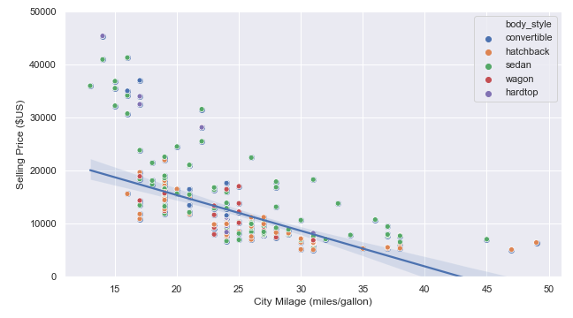

**Description :**

Figure showing a *robust* ***linear***fit between the selling price and the cars mileage in cities for all vehicle types.

**Sources:**

Simple_regression_example_using_parametric_and_non_parametric_methods.ipynb

Parametric fit (Linear fit) all cars.png

**------------------------------------------------------------------------------------------------------------------------------------------**

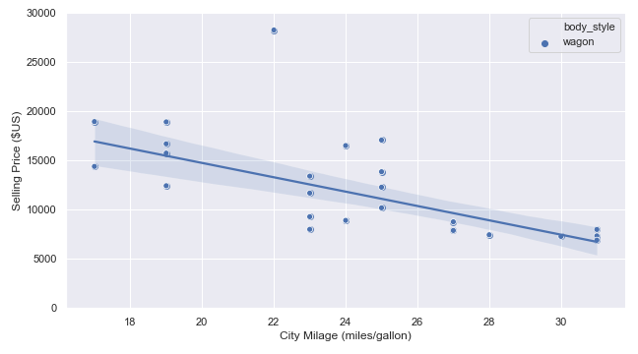

**Description :**

Figure showing a *robust* ***linear*** fit between the selling price and the cars mileage in cities for wagon vehicles only.

**Sources:**

Simple_regression_example_using_parametric_and_non_parametric_methods.ipynb

Parametric fit (Linear fit) wagon cars.png

**------------------------------------------------------------------------------------------------------------------------------------------**

**Description :**

Figure showing a *robust* ***non-linear*** fit between the selling price and the cars mileage in cities for all vehicle types.

**Sources:**

Simple_regression_example_using_parametric_and_non_parametric_methods.ipynb

Non-parametric fit (LOWESS) all cars.png

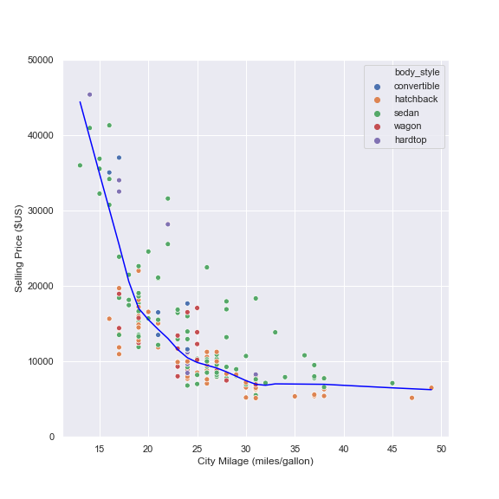

**------------------------------------------------------------------------------------------------------------------------------------------**

**Description :**

Figure showing the effect of polynomial order on fits with a **small** dataset and a **small** noise level.

**Sources:**

genere_regression_examples_with_polynomial_of various_orders.ipynb

Polynomial_fits_with_small_N_and_small_sigma.png

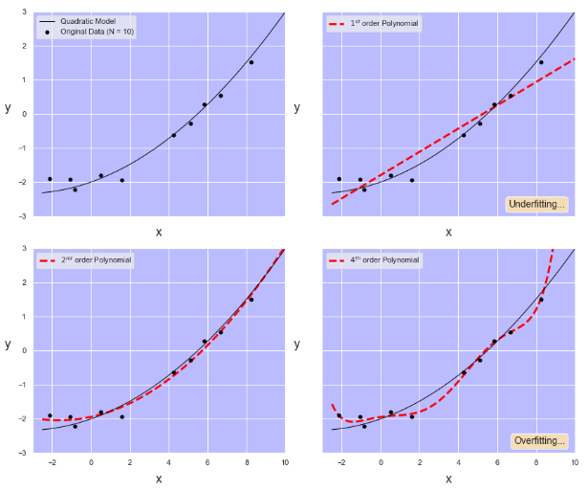

**------------------------------------------------------------------------------------------------------------------------------------------**

**Description :**

Figure showing the effect of polynomial order on fits with a **large** dataset and a **small** noise level.

**Sources:**

genere_regression_examples_with_polynomial_of various_orders.ipynb

Polynomial_fits_with_large_N_and_small_sigma.png

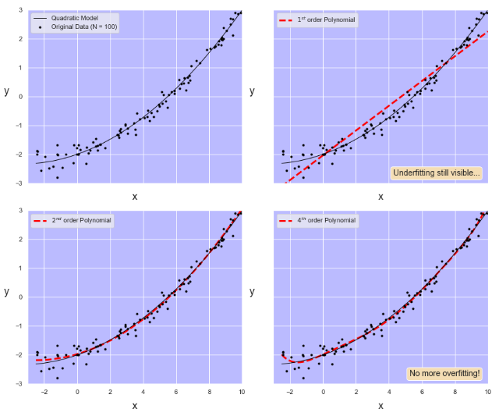

**------------------------------------------------------------------------------------------------------------------------------------------**

**Description :**

Figure showing the effect of polynomial order on fits with a **large** dataset and a **large** noise level.

**Sources:**

genere_regression_examples_with_polynomial_of various_orders.ipynb

Polynomial_fits_with_large_N_and_large_sigma.png

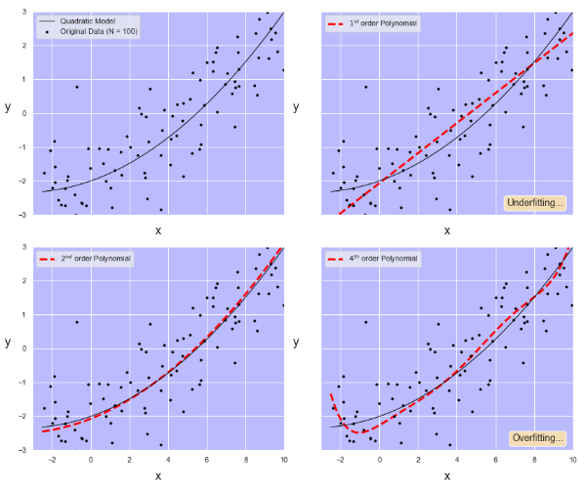

**------------------------------------------------------------------------------------------------------------------------------------------**

**Description :**

Video showing the effect of polynomial order on fits with a **large** dataset and a **small** noise level.

**Sources:**

genere_regression_examples_with_polynomial_of various_orders.ipynb

Effect_of_dataset_size_on_fits.avi

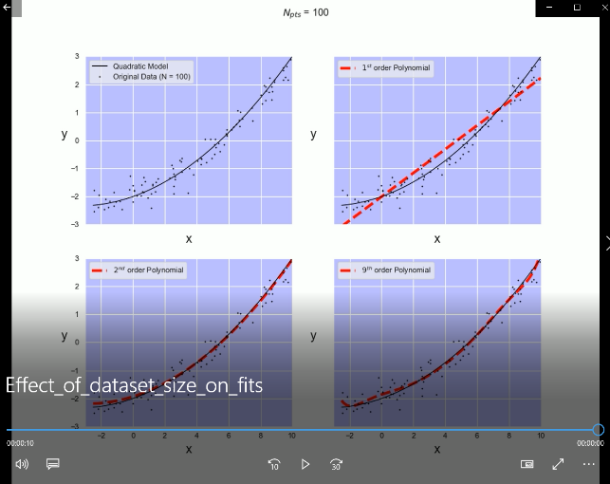

**------------------------------------------------------------------------------------------------------------------------------------------**

**Description :**

Video showing the effect of noise level on fits with a **large** dataset.

**Sources:**

genere_regression_examples_with_polynomial_of various_orders.ipynb

Effect_of_noise_level_on_fits.avi

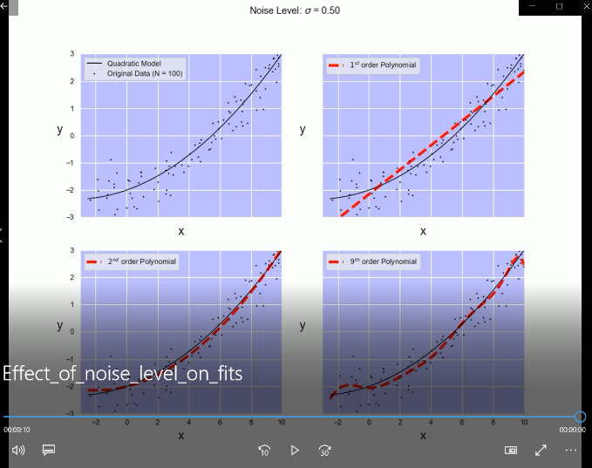

**------------------------------------------------------------------------------------------------------------------------------------------**

**Description :**

Figure the 50% boundaries for the maximum *a posteriori* probability 𝑃(𝐶𝑖|𝑋)P(Ci|X).

**Sources:**

example_of_bayesian_classification.ipynb

Bayesian classification, 50% contours.png

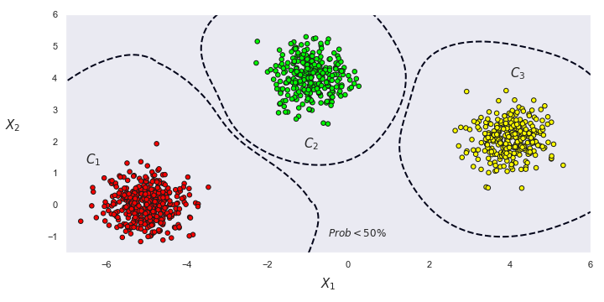

**------------------------------------------------------------------------------------------------------------------------------------------**

**Description :**

Figure showing the maximum value of the local *a posteriori* probabilities 𝑃(𝐶𝑖|𝑋)P(Ci|X).

**Sources:**

example_of_bayesian_classification.ipynb

Bayesian classification, maximum probabilities.png

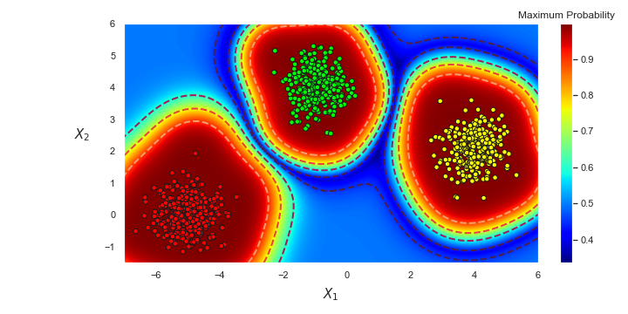

**------------------------------------------------------------------------------------------------------------------------------------------**

**Description :**

Easy 1-D example of Bayesian classification.

**Sources:**

examples_of_1D_Bayesian_classifications.ipynb

Easy 1-D Bayesian classification.png

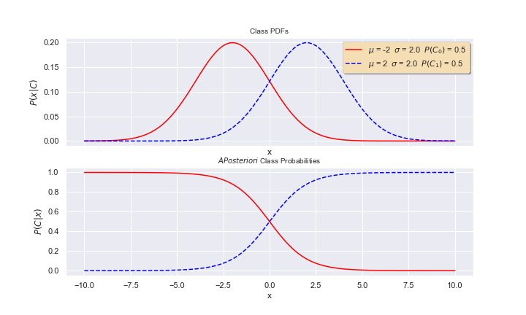

**------------------------------------------------------------------------------------------------------------------------------------------**

**Description :**

Hard 1-D example of Bayesian classification.

**Sources:**

examples_of_1D_Bayesian_classifications.ipynb

Hard 1-D Bayesian classification.png

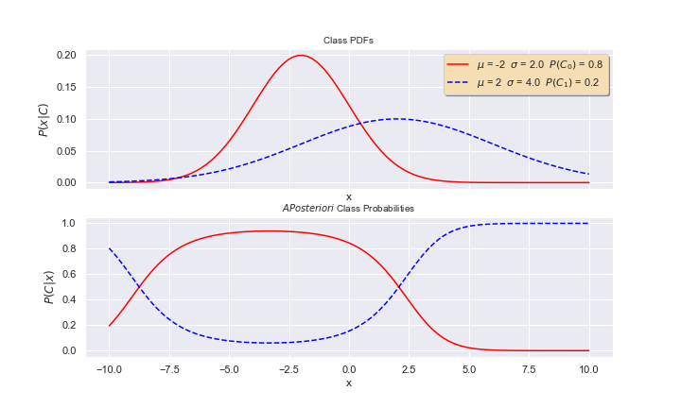

**------------------------------------------------------------------------------------------------------------------------------------------**

**Description :**

Explanation of the MSE, Bias and Variance relationship.

**Sources:**

show_links_between_MSE_overfitting_and_underfitting.ipynb

MSE_Bias_Variance.png

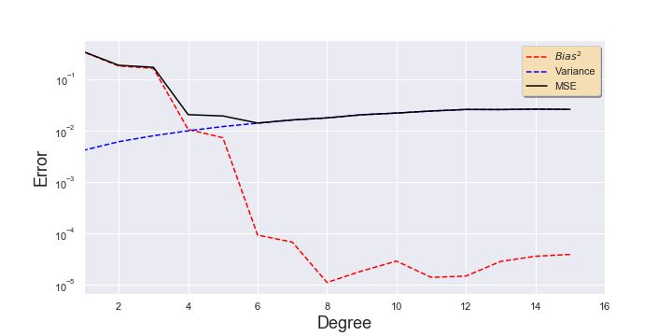

**------------------------------------------------------------------------------------------------------------------------------------------**

**Description :**

Optimal polynomial fit.

**Sources:**

show_links_between_MSE_overfitting_and_underfitting.ipynb

Optimum polynomial fit.png

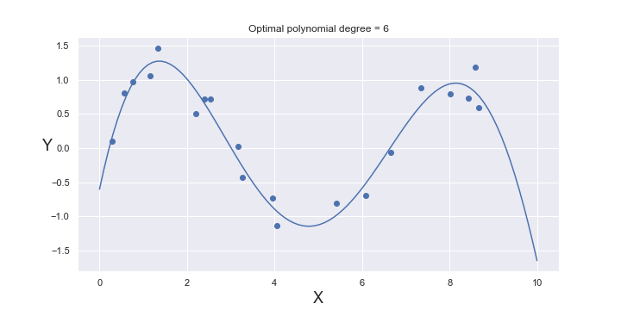

**------------------------------------------------------------------------------------------------------------------------------------------**

**Description :**

How does the MSE vary with polynomial degree?

**Sources:**

show_links_between_MSE_overfitting_and_underfitting.ipynb

MSE varies with polynomial degree.png

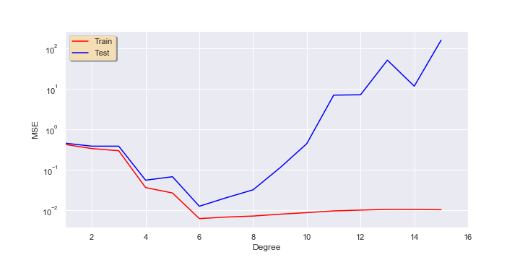

**------------------------------------------------------------------------------------------------------------------------------------------**

**Description :**

Various examples of polynomial fits showing bias and variability

**Sources:**

show_links_between_MSE_overfitting_and_underfitting.ipynb

Various examples of polynomial fits.png

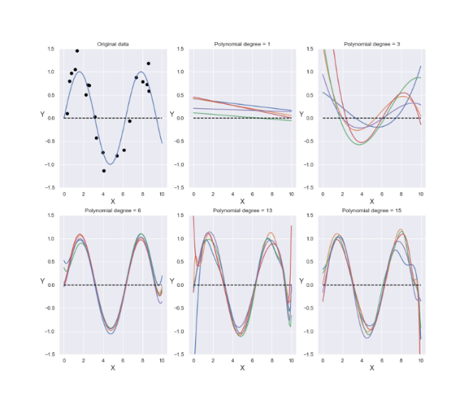

**------------------------------------------------------------------------------------------------------------------------------------------**

**Description :**

Examples of 2-D PDF with isotropy and correlation

**Sources:**

genere_examples_of_PDF_isotropy_and_correlation.ipynb

Examples_of_PDF_isotropy_and_correlation.png

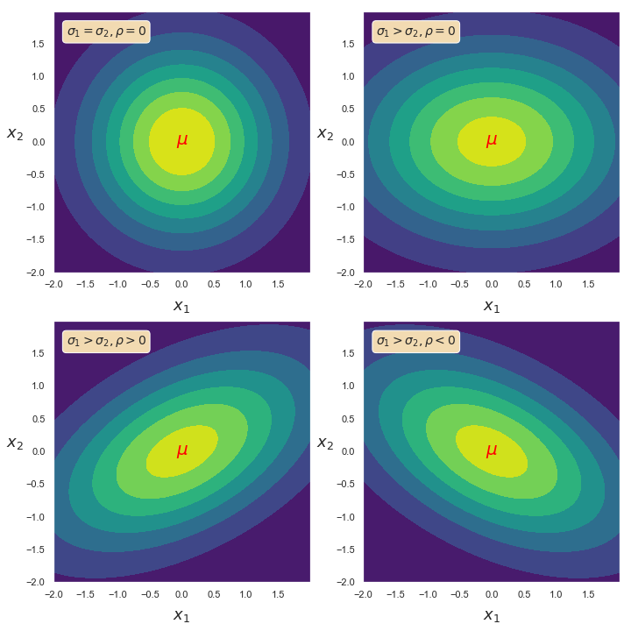

**------------------------------------------------------------------------------------------------------------------------------------------**

**Description :**

Example of 2D PDF with conditional 1D probabilities

**Sources:**

generate_example_of_2D_PDF_with_conditional_1D_PDF.ipynb

Example_of_2D_PDF_with_conditional_1D.png

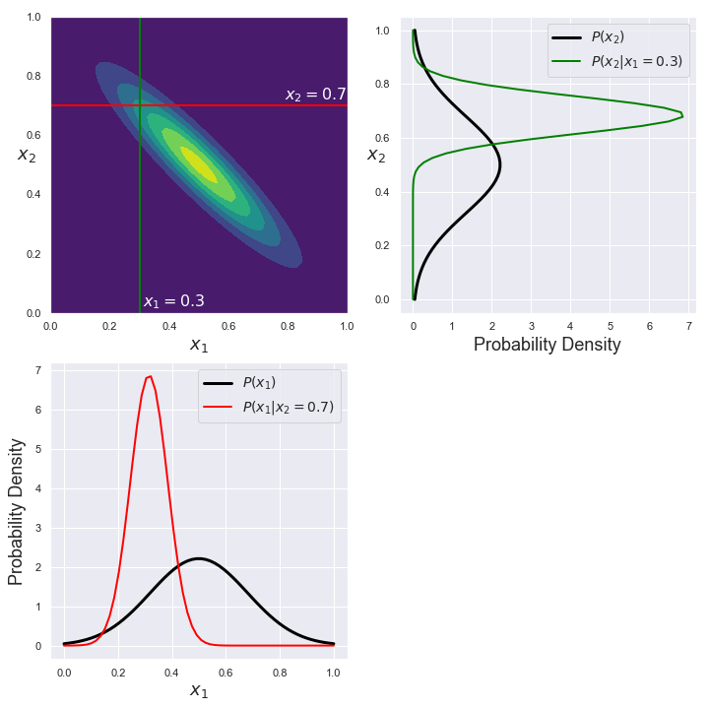

**------------------------------------------------------------------------------------------------------------------------------------------**

**Description :**

Example_of_isotropic_2D_gaussian_PDF_without_correlation

**Sources:**

generate_examples_of_2D_gaussian_PDF.ipynb

Example_of_isotropic_2D_gaussian_PDF_without_correlation.png

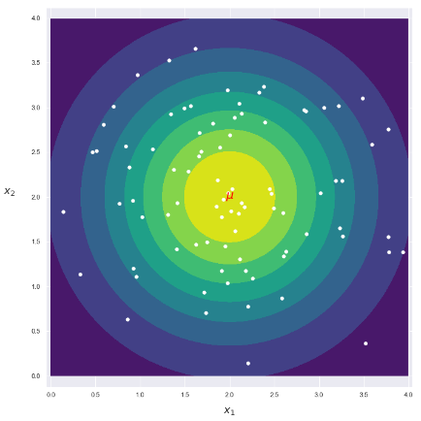

**------------------------------------------------------------------------------------------------------------------------------------------**

**Description :**

Example_of_anisotropic_2D_gaussian_PDF_without_correlation

**Sources:**

generate_examples_of_2D_gaussian_PDF.ipynb

Example_of_anisotropic_2D_gaussian_PDF_without_correlation.png

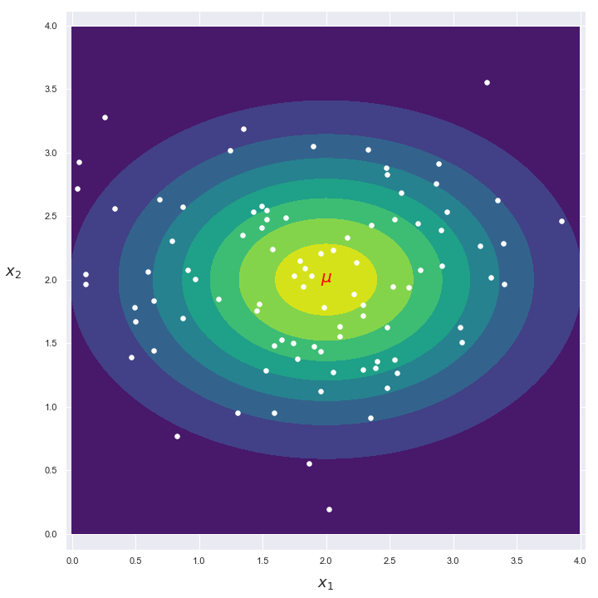

**------------------------------------------------------------------------------------------------------------------------------------------**

**Description :**

Example_of_correlated_2D_gaussian_PDF

**Sources:**

generate_examples_of_2D_gaussian_PDF.ipynb

Example_of_correlated_2D_gaussian_PDF.png

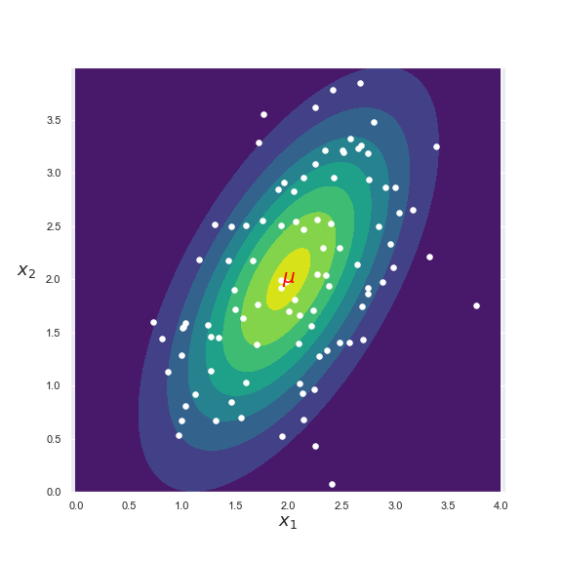

**------------------------------------------------------------------------------------------------------------------------------------------**

**Description :**

Explanatory diagram for influence zones in 2-class segmentation

**Sources:**

generate_explanatory_diagram_for_influence_zones_in_two_class_segmentation.ipynb

Influence_zones_in_gaussian_PDF_classification.png

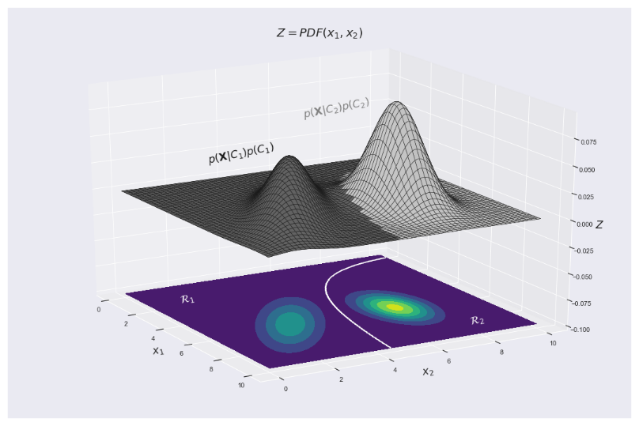

**------------------------------------------------------------------------------------------------------------------------------------------**

**Description :**

Generate surface classification examples with LDA and QDA methods

**Sources:**

Generate_surface_classification_examples_with_LDA_and_QDA_methods.ipynb

Surface_classification_examples_with_LDA_and_QDA_methods.png

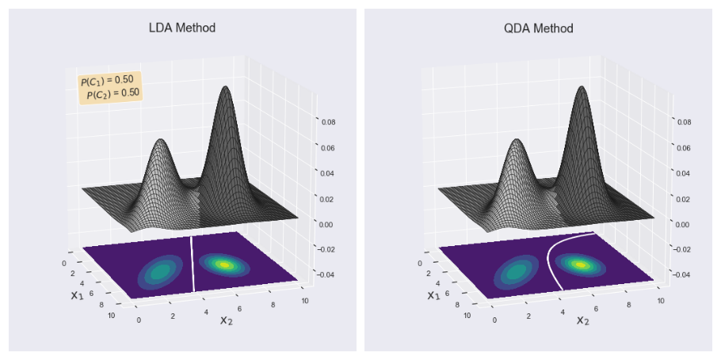

**------------------------------------------------------------------------------------------------------------------------------------------**

**Description :**

Generate surface classification examples with LDA and QDA methods; P(C1)=20%, P(C2)=80%

**Sources:**

Generate_surface_classification_examples_with_LDA_and_QDA_methods.ipynb

Surface_classification_examples_with_LDA_and_QDA_methods_20%_80%.png

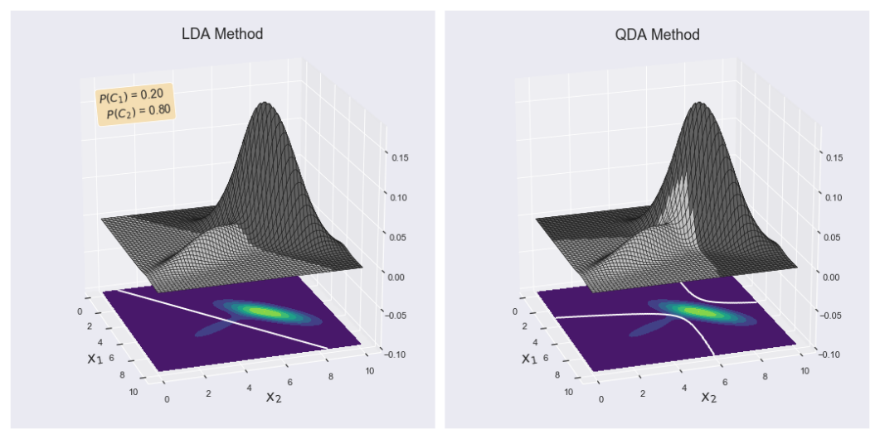

**------------------------------------------------------------------------------------------------------------------------------------------**

**Description :**

Generate surface classification examples with LDA and QDA methods; P(C1)=50%, P(C2)=50%

**Sources:**

Generate_surface_classification_examples_with_LDA_and_QDA_methods.ipynb

Surface_classification_examples_with_LDA_and_QDA_methods_50%_50%.png

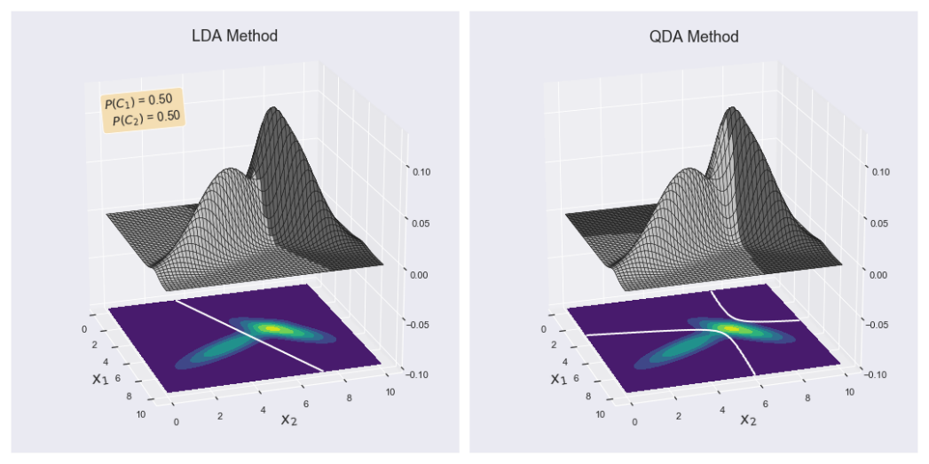

**------------------------------------------------------------------------------------------------------------------------------------------**

**Description :**

Generate surface classification examples with LDA and QDA methods; P(C1)=80%, P(C2)=20%

**Sources:**

Generate_surface_classification_examples_with_LDA_and_QDA_methods.ipynb

Surface_classification_examples_with_LDA_and_QDA_methods_80%_20%.png

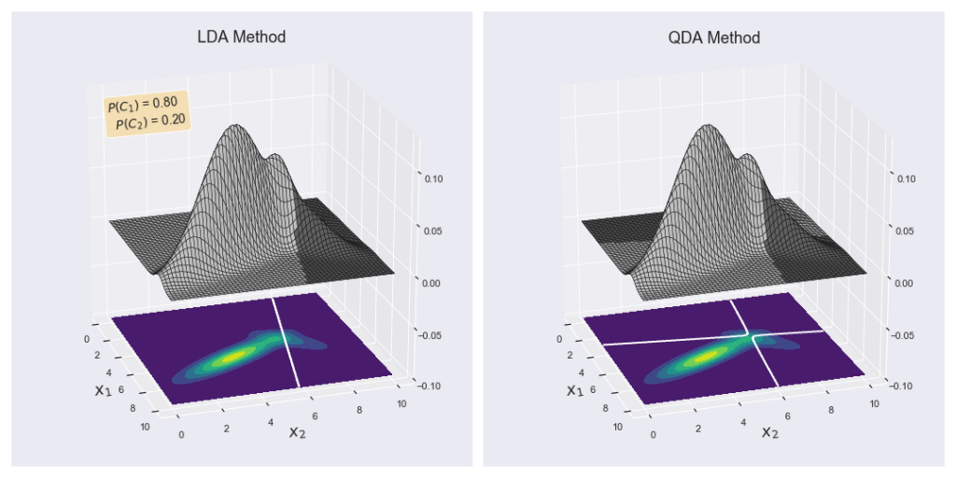

**------------------------------------------------------------------------------------------------------------------------------------------**

**Description :**

**Different distributions with the same *a priori* probability**𝑃(𝐶𝑖)=50%

**Sources:**

generate_3D_classification_examples_with_LDA_QDA_NaiveBayes_NearestCentroid_methods.ipynb

3D_classification_4_methods_1.png

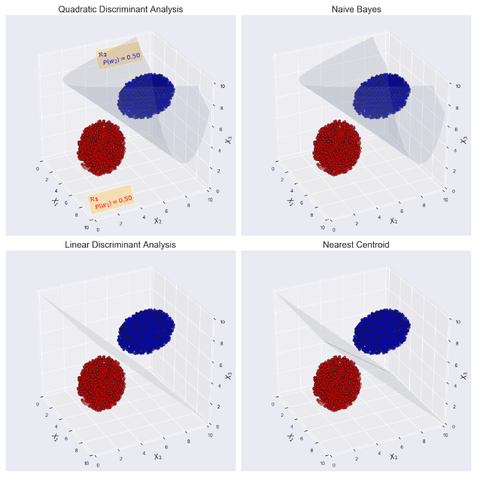

**------------------------------------------------------------------------------------------------------------------------------------------**

**Description :**

**Different distributions with very different *a priori* probabilities**𝑃(𝐶𝑖)

**Sources:**

generate_3D_classification_examples_with_LDA_QDA_NaiveBayes_NearestCentroid_methods.ipynb

3D_classification_4_methods_2.png

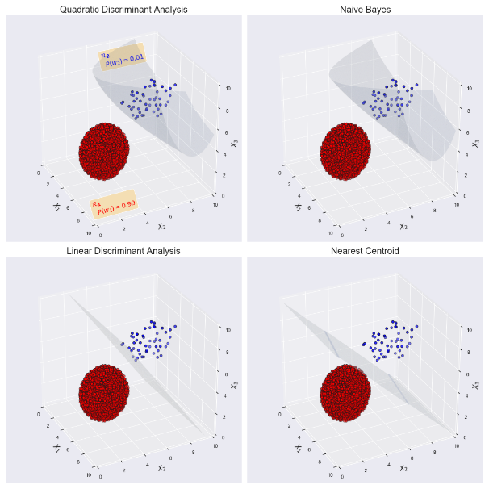

**------------------------------------------------------------------------------------------------------------------------------------------**

**Description :**

**Identical distributions with the same *a priori* probability**𝑃(𝐶𝑖)=50%

**Sources:**

generate_3D_classification_examples_with_LDA_QDA_NaiveBayes_NearestCentroid_methods.ipynb

3D_classification_4_methods_3.png

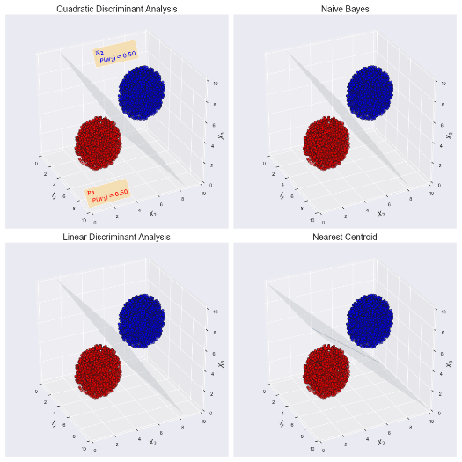

**------------------------------------------------------------------------------------------------------------------------------------------**

**Description :**

### Identical spherical distributions with the same *a priori* probability 𝑃(𝐶𝑖)=50%

**Sources:**

generate_3D_classification_examples_with_LDA_QDA_NaiveBayes_NearestCentroid_methods.ipynb

3D_classification_4_methods_4.png

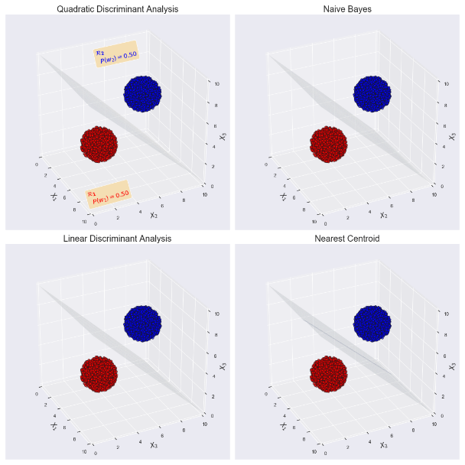

**------------------------------------------------------------------------------------------------------------------------------------------**

**Description :**

**Identical spherical distributions with very different *a priori* probabilities**𝑃(𝐶𝑖)**Sources:**

generate_3D_classification_examples_with_LDA_QDA_NaiveBayes_NearestCentroid_methods.ipynb

3D_classification_4_methods_5.png

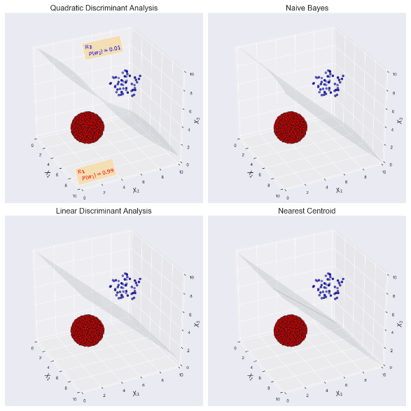

**------------------------------------------------------------------------------------------------------------------------------------------**

**Description :**

### Superposed spherical and ellipsoidal distributions with the same *a priori* probability 𝑃(𝐶𝑖)=50%

**Sources:**

generate_3D_classification_examples_with_LDA_QDA_NaiveBayes_NearestCentroid_methods.ipynb

3D_classification_4_methods_6.png

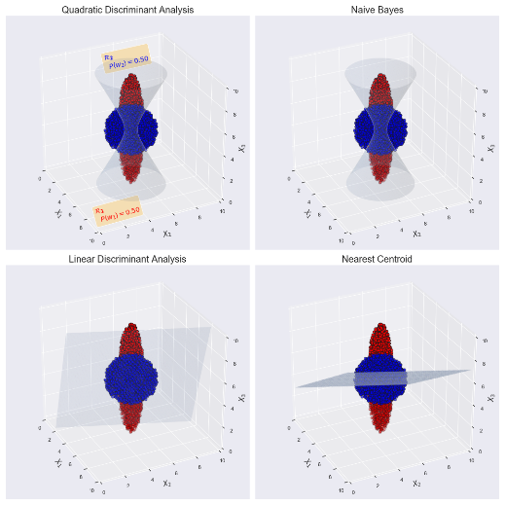

**------------------------------------------------------------------------------------------------------------------------------------------**

**Description :**

**Touching spherical and ellipsoidal distributions with the same *a priori* probability**𝑃(𝐶𝑖)=50%

**Sources:**

generate_3D_classification_examples_with_LDA_QDA_NaiveBayes_NearestCentroid_methods.ipynb

3D_classification_4_methods_7.png

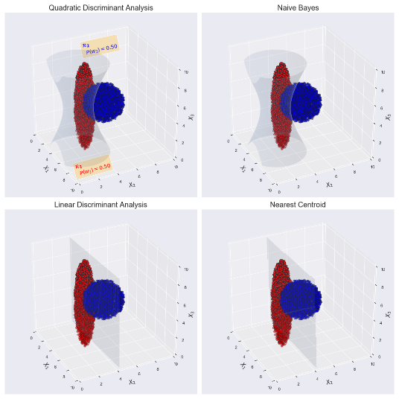

**------------------------------------------------------------------------------------------------------------------------------------------**

**Description :**

### Separated spherical and ellipsoidal distributions with the same *a priori* probability 𝑃(𝐶𝑖)=50%

**Sources:**

generate_3D_classification_examples_with_LDA_QDA_NaiveBayes_NearestCentroid_methods.ipynb

3D_classification_4_methods_8.png

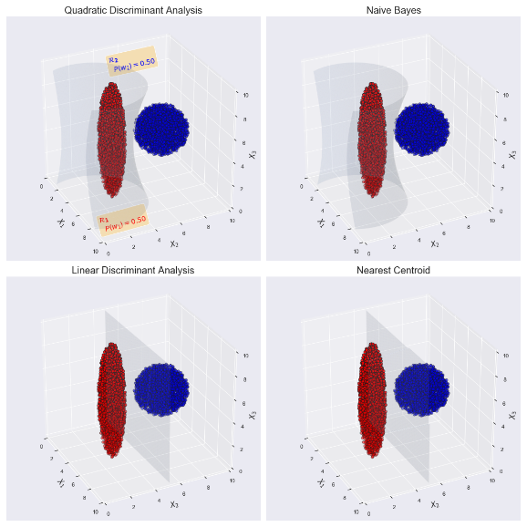

**------------------------------------------------------------------------------------------------------------------------------------------**

**Description :**

**2D_classification_examples_with_LDA_and_QDA_methods:**

Generate_2D_classification_examples_with_LDA_and_QDA_methods.ipynb

'Classification_examples_with_LDA_and_QDA_methods_1.png

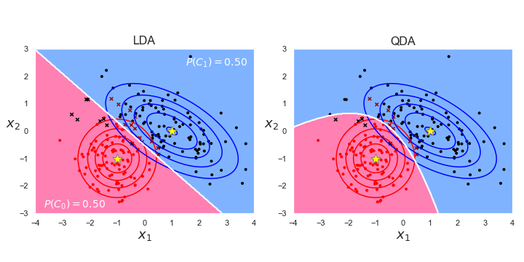

**------------------------------------------------------------------------------------------------------------------------------------------**

**Description :**

**2D_classification_examples_with_LDA_and_QDA_methods:**

Generate_2D_classification_examples_with_LDA_and_QDA_methods.ipynb

'Classification_examples_with_LDA_and_QDA_methods_2.png

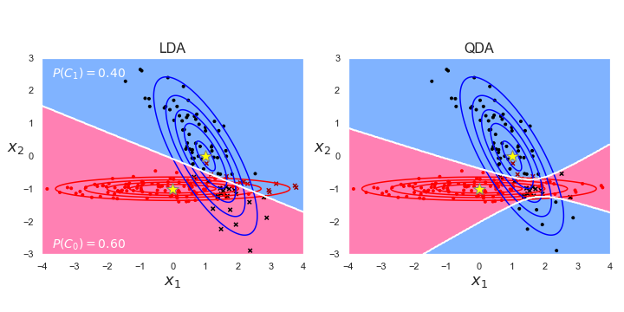

**------------------------------------------------------------------------------------------------------------------------------------------**

**Description :**

**2D_classification_examples_with_LDA_and_QDA_methods:**

Generate_2D_classification_examples_with_LDA_and_QDA_methods.ipynb

'Classification_examples_with_LDA_and_QDA_methods_3.png

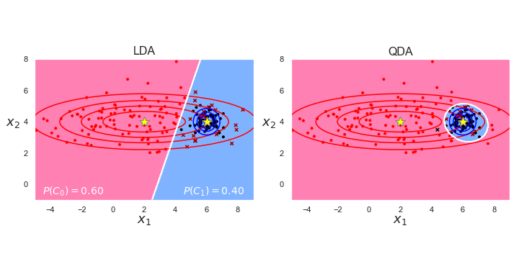

**------------------------------------------------------------------------------------------------------------------------------------------**

**Description :**

**2D_classification_examples_with_LDA_and_QDA_methods:**

Generate_2D_classification_examples_with_LDA_and_QDA_methods.ipynb

'Classification_examples_with_LDA_and_QDA_methods_4.png

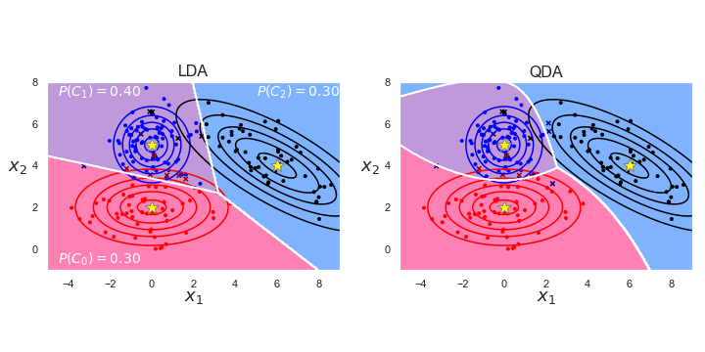

**------------------------------------------------------------------------------------------------------------------------------------------**

**Description :**

**3D_classification_examples_with_LDA_method: P(C1) = 1%**

generate_3D_LDA_segmentations_with_influences_zones.ipynb

3D_LDA_classification_0.01.png

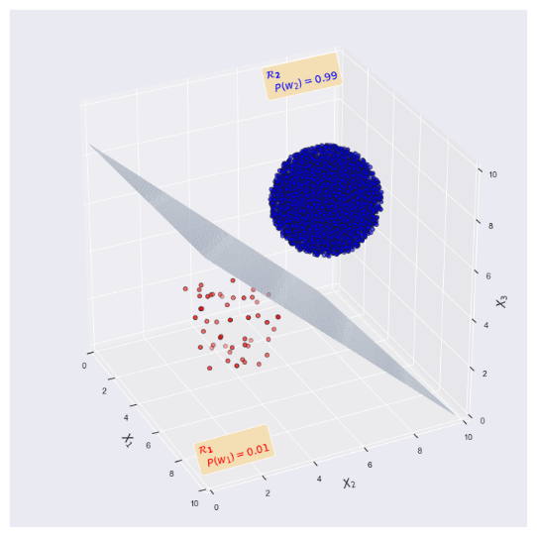

**------------------------------------------------------------------------------------------------------------------------------------------**

**Description :**

**3D_classification_examples_with_LDA_method: P(C1) = 50%**

generate_3D_LDA_segmentations_with_influences_zones.ipynb

3D_LDA_classification_0.50.png

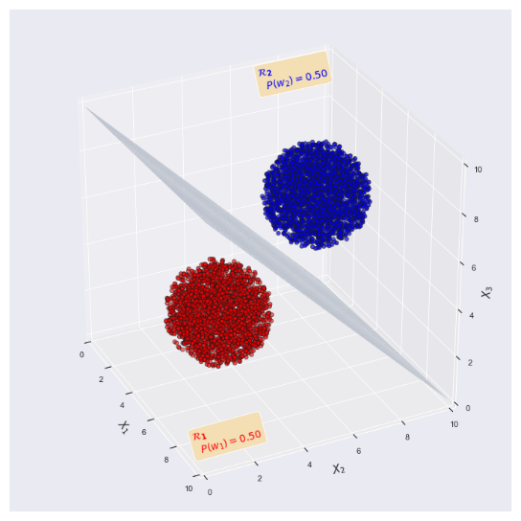

**------------------------------------------------------------------------------------------------------------------------------------------**

**Description :**

**3D_classification_examples_with_LDA_method: P(C1) = 99%**

generate_3D_LDA_segmentations_with_influences_zones.ipynb

3D_LDA_classification_0.99.png

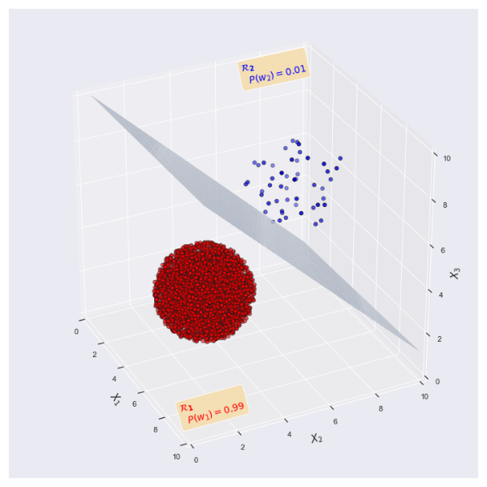

**------------------------------------------------------------------------------------------------------------------------------------------**

**Description :**

**QDA classification results for 2 gaussian PDF generated with 100 data points**

effect_of_number_of_data_points_on_classification_results.ipynb

Classification_results_for_2_gaussian_PDF_generated_with_100_data_points.png

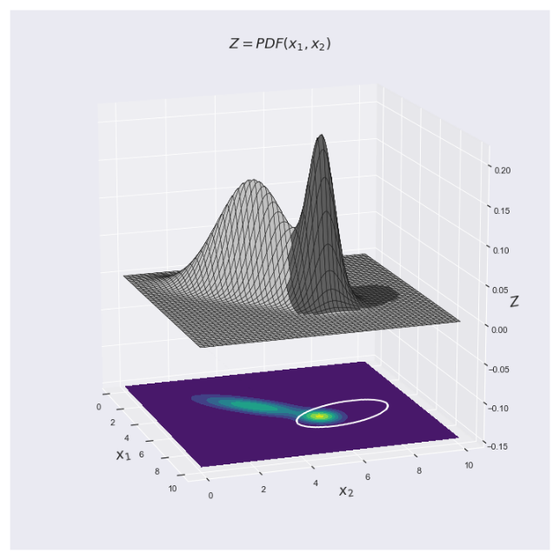

**------------------------------------------------------------------------------------------------------------------------------------------**

**Description :**

**QDA classification results for 2 gaussian PDF generated with 1000 data points**

effect_of_number_of_data_points_on_classification_results.ipynb

Classification_results_for_2_gaussian_PDF_generated_with_1000_data_points.png

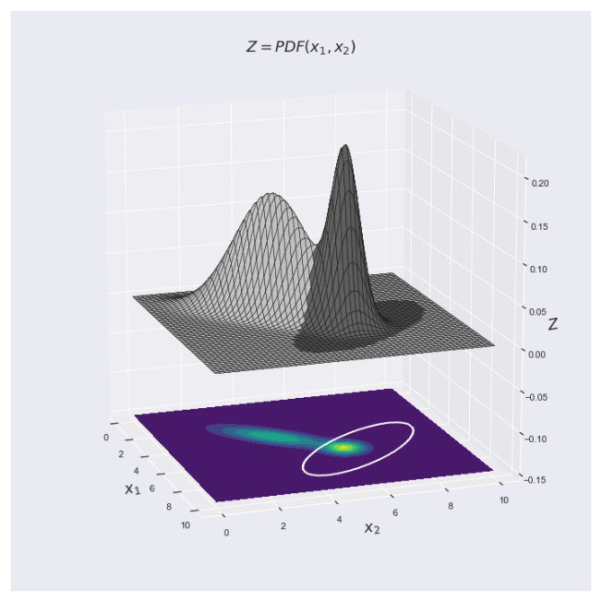

**------------------------------------------------------------------------------------------------------------------------------------------**

**Description :**

**QDA classification results for 2 gaussian PDF generated with 10, 000 data points**

effect_of_number_of_data_points_on_classification_results.ipynb

Classification_results_for_2_gaussian_PDF_generated_with_10K_data_points.png

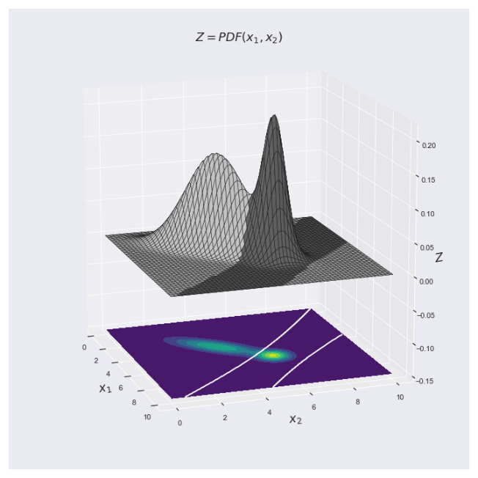

**------------------------------------------------------------------------------------------------------------------------------------------**

**Description :**

**QDA classification results for 2 gaussian PDF generated with 100, 000 data points**

effect_of_number_of_data_points_on_classification_results.ipynb

Classification_results_for_2_gaussian_PDF_generated_with_100K_data_points.png

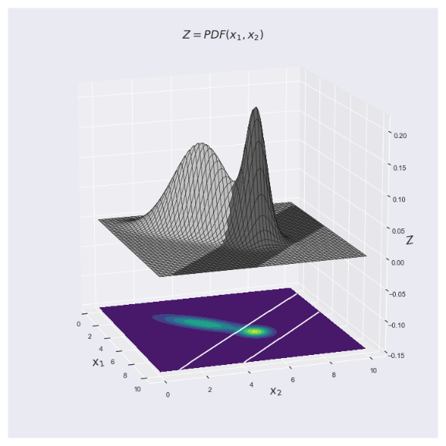

**------------------------------------------------------------------------------------------------------------------------------------------**

**Description :**

# **Various examples of 2-D classification using QDA**

Detailed_example_of_QDA_classification.ipynb

Various_2D_classification_examples_with_quadratic_discriminant_1.png

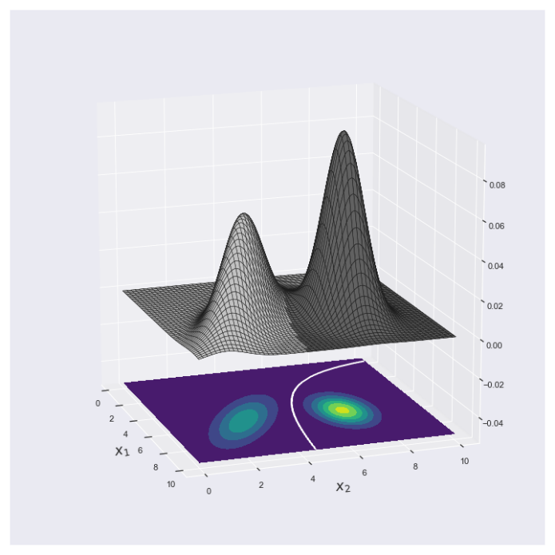

**------------------------------------------------------------------------------------------------------------------------------------------**

**Description :**

# **Various examples of 2-D classification using QDA**

Detailed_example_of_QDA_classification.ipynb

Various_2D_classification_examples_with_quadratic_discriminant_2.png

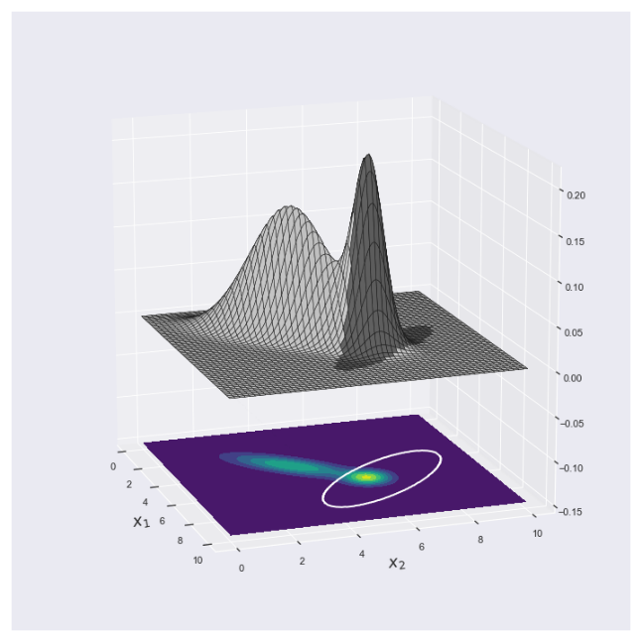

**------------------------------------------------------------------------------------------------------------------------------------------**

**Description :**

# **Various examples of 2-D classification using QDA**

Detailed_example_of_QDA_classification.ipynb

Various_2D_classification_examples_with_quadratic_discriminant_3.png

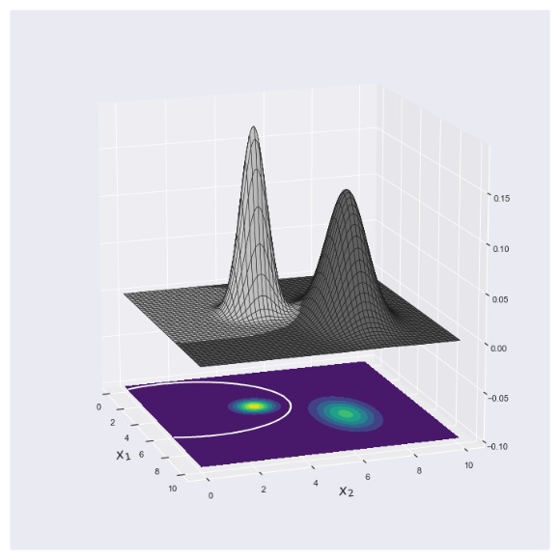

**------------------------------------------------------------------------------------------------------------------------------------------**

**Description :**

# **Various examples of 2-D classification using QDA**

Detailed_example_of_QDA_classification.ipynb

Various_2D_classification_examples_with_quadratic_discriminant_4.png

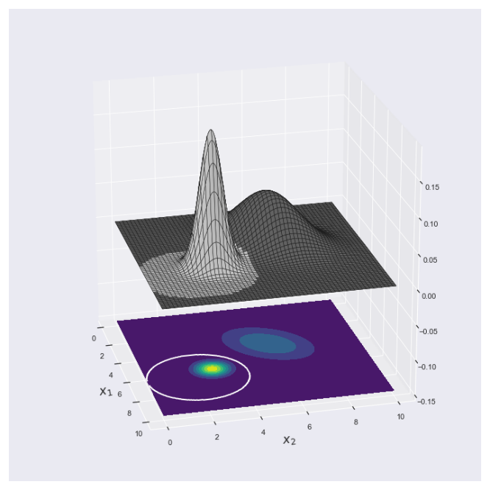

**------------------------------------------------------------------------------------------------------------------------------------------**

**Description :**

# **Various examples of 2-D classification using QDA**

Detailed_example_of_QDA_classification.ipynb

Various_2D_classification_examples_with_quadratic_discriminant_5.png

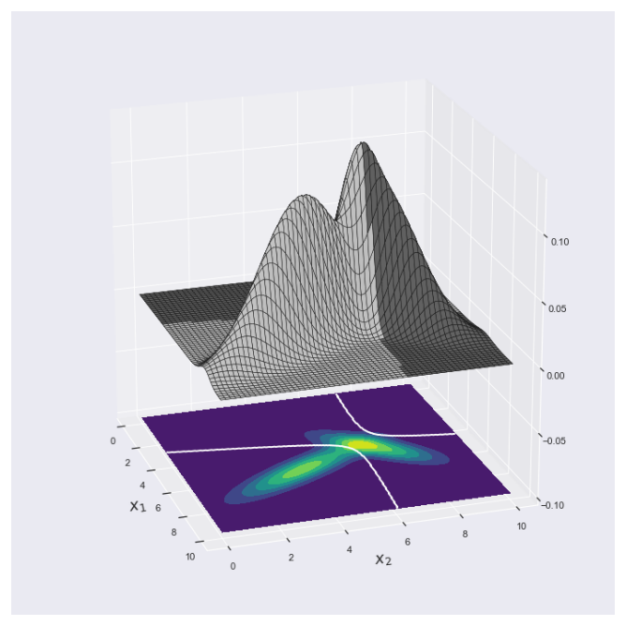

**------------------------------------------------------------------------------------------------------------------------------------------**

**Description :**

# **Various examples of 2-D classification using QDA**

Detailed_example_of_QDA_classification.ipynb

Various_2D_classification_examples_with_quadratic_discriminant_6.png

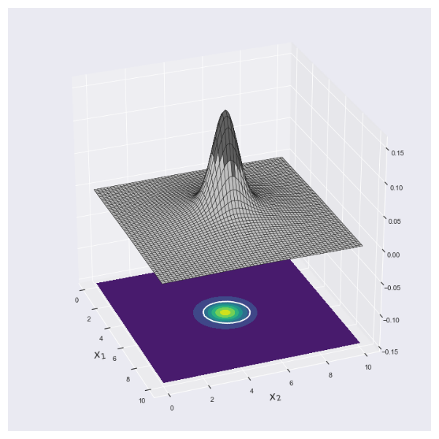

**------------------------------------------------------------------------------------------------------------------------------------------**

**Description :**

# **Various examples of 2-D classification using QDA**

generate_surface_visualizations_of_2D_gaussian_PDF.ipynb

Surface_visualization_of_2D_gaussian_PDF_without_correlation.png

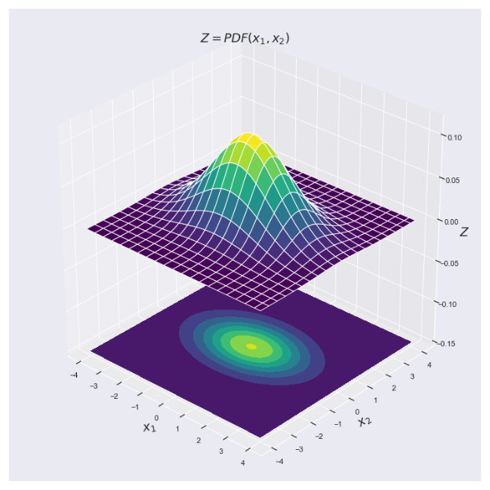

**------------------------------------------------------------------------------------------------------------------------------------------**

**Description :**

# **Various examples of 2-D classification using QDA**

generate_surface_visualizations_of_2D_gaussian_PDF.ipynb

Surface_visualization_of_2D_gaussian_PDF_with_correlation.png

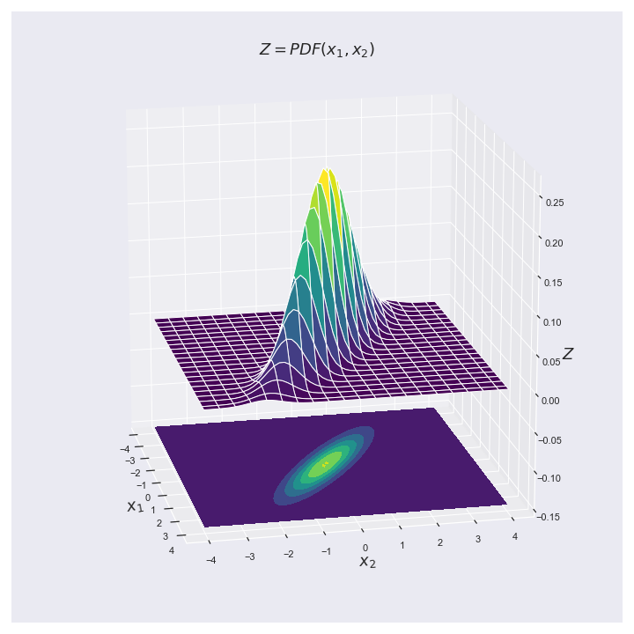

**------------------------------------------------------------------------------------------------------------------------------------------**

**Description :**

# **1-D PDF estimation reference model**

PDF_estimation_using_histogram_and_KDE_methods.ipynb

1D_PDF_estimation_reference.png

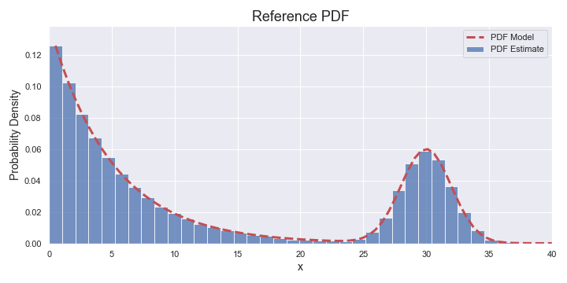

**------------------------------------------------------------------------------------------------------------------------------------------**

**Description :**

# **1-D PDF estimation: standard histogram method and variable width**

PDF_estimation_using_histogram_and_KDE_methods.ipynb

1D_PDF_estimation_std_hist_variable_width.png

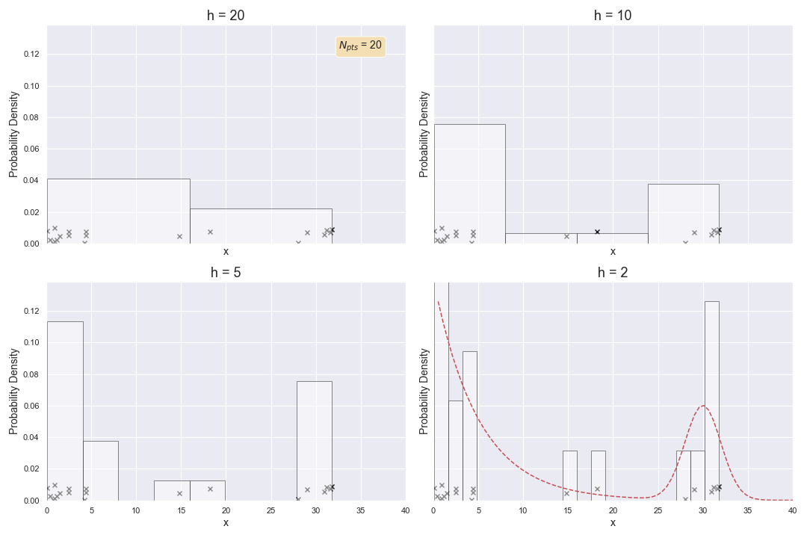

**------------------------------------------------------------------------------------------------------------------------------------------**

**Description :**

# **1-D PDF estimation: naive histogram method and variable width**

PDF_estimation_using_histogram_and_KDE_methods.ipynb

1D_PDF_estimation_naive_variable_width.png

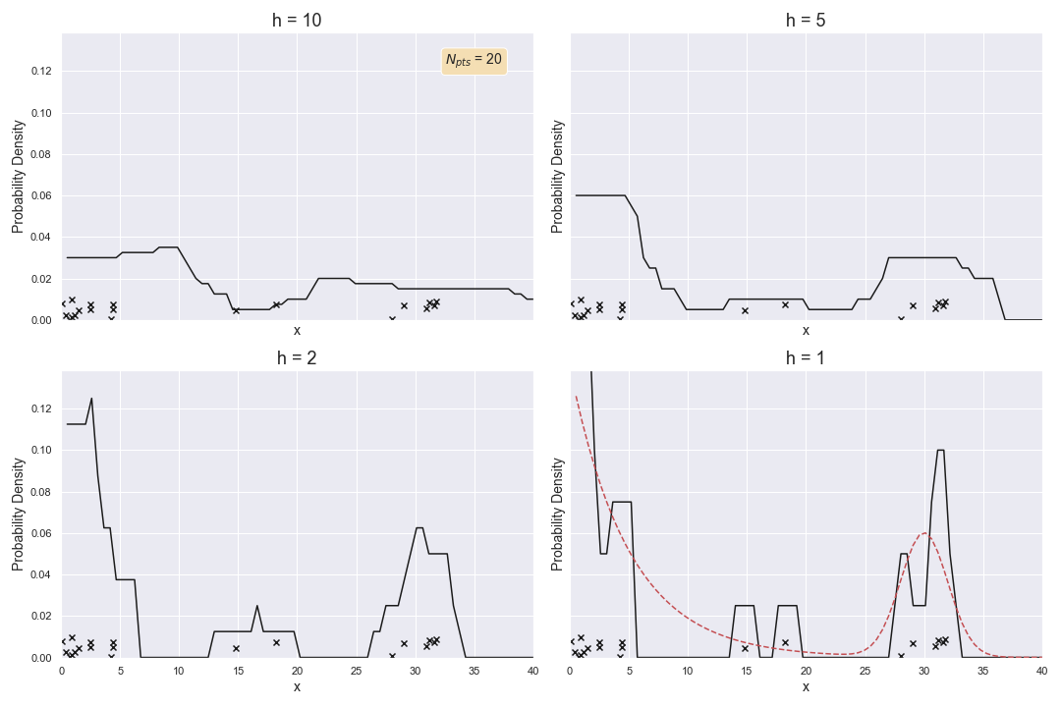

**------------------------------------------------------------------------------------------------------------------------------------------**

**Description :**

# **Several kernels for kernel density estimation (KDE) methods**

PDF_estimation_using_histogram_and_KDE_methods.ipynb

1D_PDF_estimation_various_kernels.png

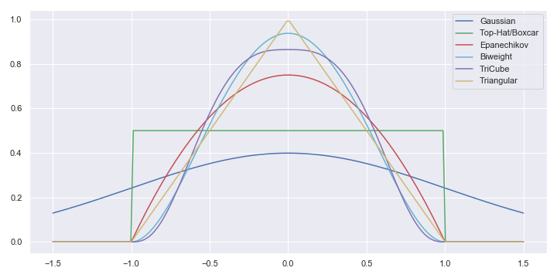

**------------------------------------------------------------------------------------------------------------------------------------------**

**Description :**

# **1-D PDF estimation: gaussian KDE method and variable bandwidth**

PDF_estimation_using_histogram_and_KDE_methods.ipynb

1D_PDF_estimation_gaussian_KDE_variable_bandwidth.png

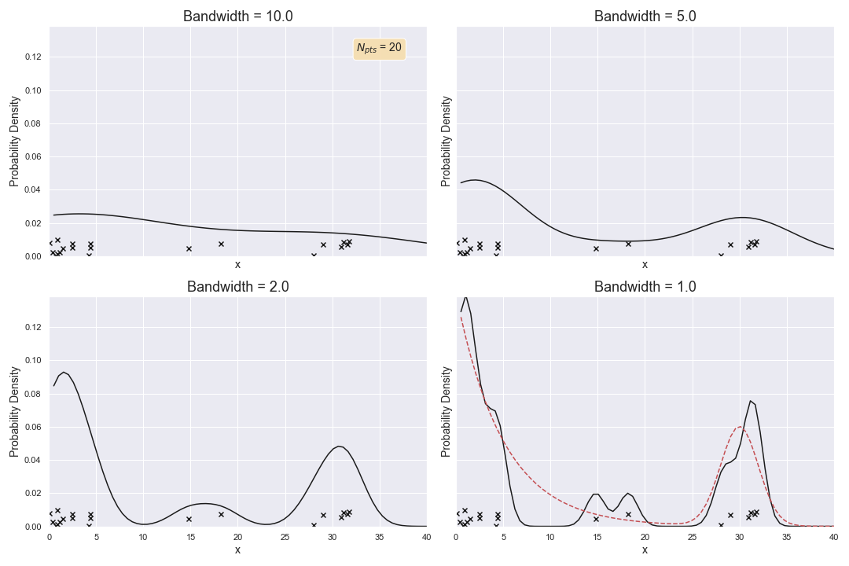

**------------------------------------------------------------------------------------------------------------------------------------------**

**Description :**

# **1-D PDF estimation: gaussian KDE method with variable bandwidth and Npts**

PDF_estimation_using_histogram_and_KDE_methods.ipynb

1D_PDF_estimation_gaussian_KDE_variable_bandwidth_npts.png

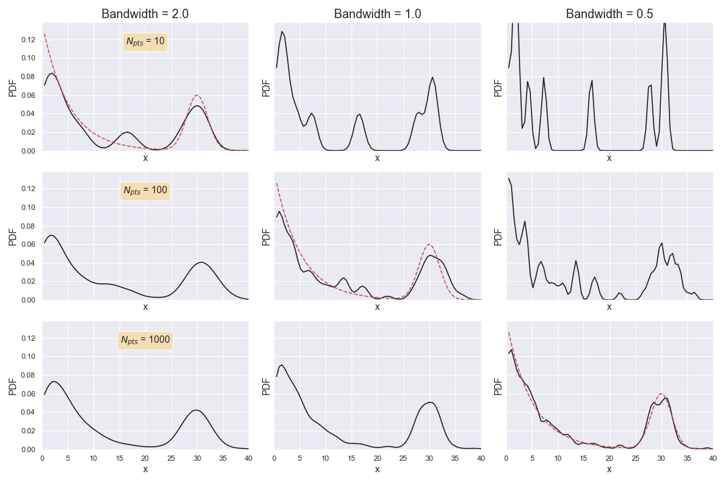

**------------------------------------------------------------------------------------------------------------------------------------------**

**Description :**

# **1-D PDF estimation: KDE method with variable kernels and bandwidth=1**

PDF_estimation_using_histogram_and_KDE_methods.ipynb

1D_PDF_estimation_various_KDE_kernels_bandwidth_1.png

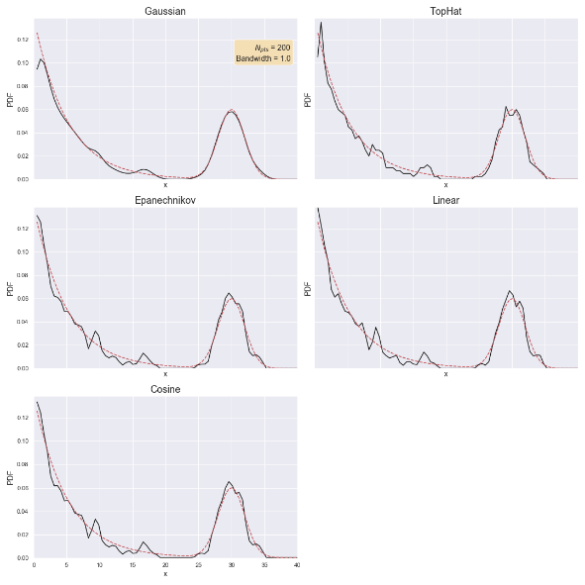

**------------------------------------------------------------------------------------------------------------------------------------------**

**Description :**

# **1-D PDF estimation: KDE method with variable kernels and bandwidth=2**

PDF_estimation_using_histogram_and_KDE_methods.ipynb

1D_PDF_estimation_various_KDE_kernels_bandwidth_2.png

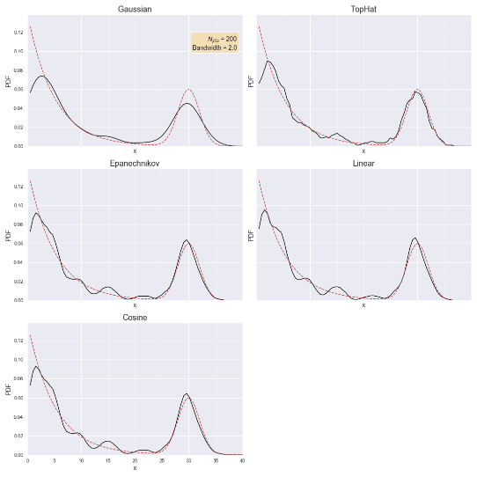

**------------------------------------------------------------------------------------------------------------------------------------------**

**Description :**

# **1-D PDF estimation: std hist versus KDE with Epanechnikov kernel**

PDF_estimation_using_histogram_and_KDE_methods.ipynb

1D_PDF_estimation_std_hist_versus_KDE_𝐄𝐩𝐚𝐧𝐞𝐜𝐡𝐧𝐢𝐤𝐨𝐯.png

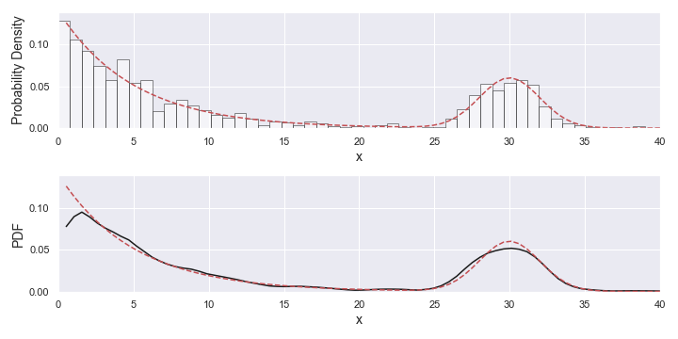

**------------------------------------------------------------------------------------------------------------------------------------------**

**Description :**

# **2-D dataset with reference PDF**

2D_PDF_estimation_using_histogram_and_KDE_methods.ipynb

2D_PDF_estimation_dataset_and_true_PDF.png

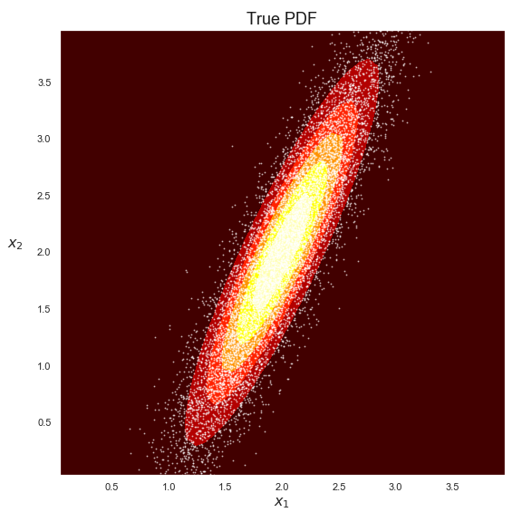

**------------------------------------------------------------------------------------------------------------------------------------------**

**Description :**

# **2-D histogram-based PDF estimation**

2D_PDF_estimation_using_histogram_and_KDE_methods.ipynb

2D_PDF_histogram_based_PDF.png

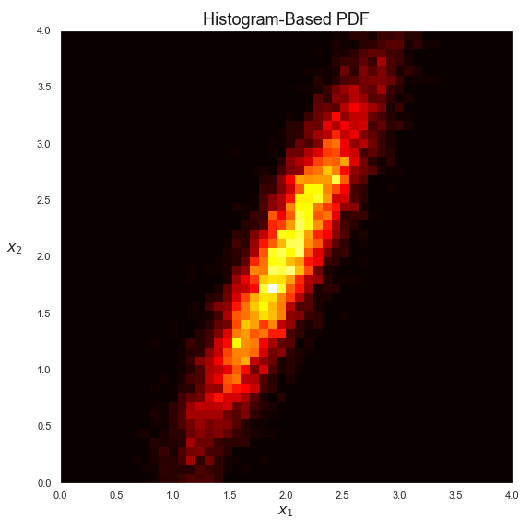

**------------------------------------------------------------------------------------------------------------------------------------------**

**Description :**

# **Comparison of several 2-D PDF estimations with too small bandwidth values**

2D_PDF_estimation_using_histogram_and_KDE_methods.ipynb

2D_PDF_estimation_bw_too_small.png

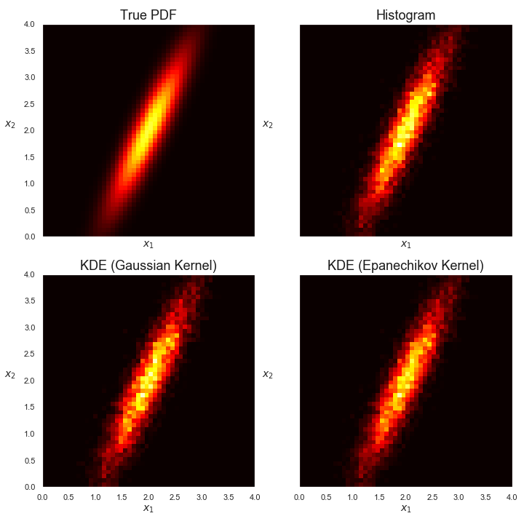

**------------------------------------------------------------------------------------------------------------------------------------------**

**Description :**

# **Comparison of several conditional PDF estimations with too small bandwidth values**

2D_PDF_estimation_using_histogram_and_KDE_methods.ipynb

2D_PDF_conditional_bw_too_small.png

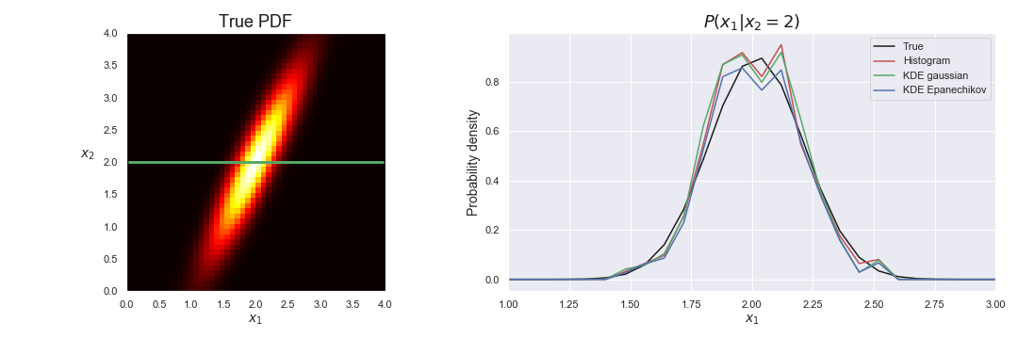

**------------------------------------------------------------------------------------------------------------------------------------------**

**Description :**

# **Comparison of several 2-D PDF estimations with too large bandwidth values**

2D_PDF_estimation_using_histogram_and_KDE_methods.ipynb

2D_PDF_estimation_bw_too_large.png

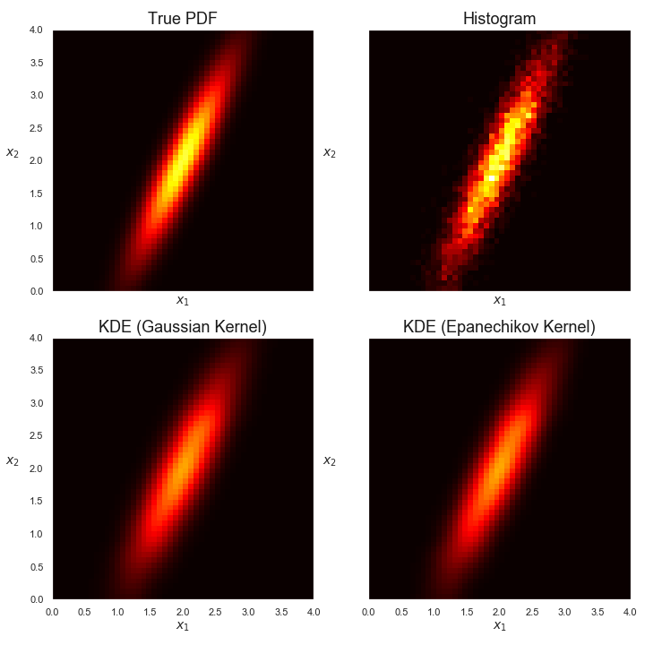

**------------------------------------------------------------------------------------------------------------------------------------------**

**Description :**

# **Comparison of several conditional PDF estimations with too large bandwidth values**

2D_PDF_estimation_using_histogram_and_KDE_methods.ipynb

2D_PDF_conditional_bw_too_large.png

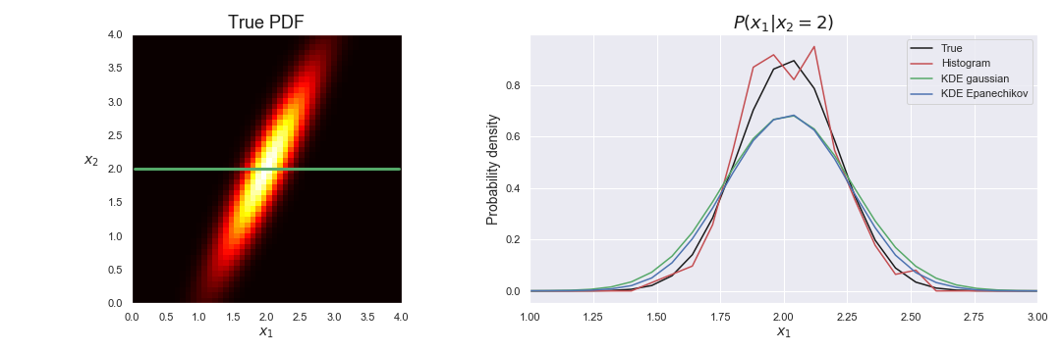

**------------------------------------------------------------------------------------------------------------------------------------------**

**Description :**

# **Comparison of several 2-D PDF estimations with just right bandwidth values**

2D_PDF_estimation_using_histogram_and_KDE_methods.ipynb

2D_PDF_estimation_bw_just_right.png

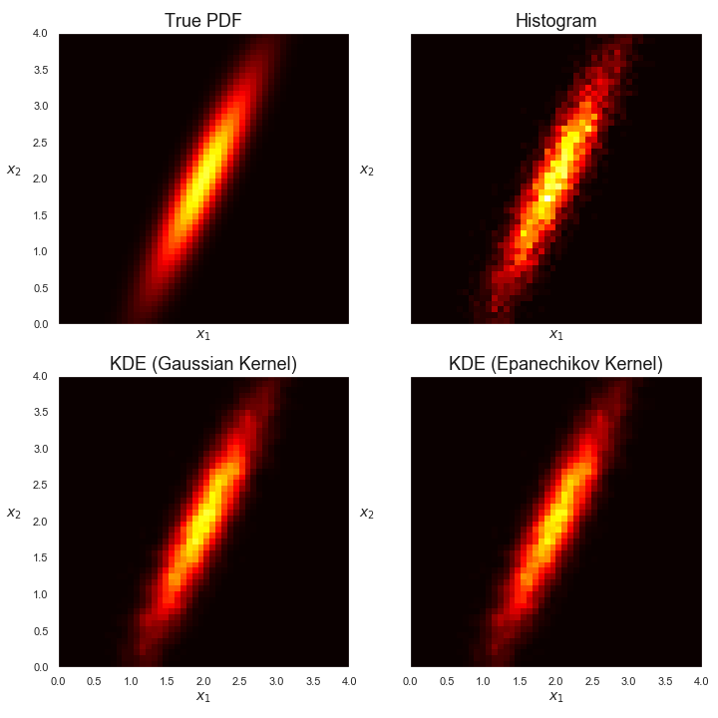

**------------------------------------------------------------------------------------------------------------------------------------------**

**Description :**

# **Comparison of several conditional PDF estimations with just right bandwidth values**

2D_PDF_estimation_using_histogram_and_KDE_methods.ipynb

2D_PDF_conditional_bw_just_right.png

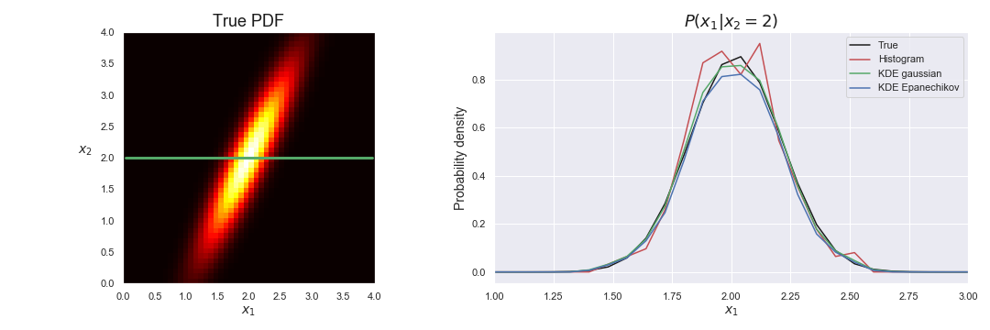

**------------------------------------------------------------------------------------------------------------------------------------------**

**Description :**

# **Comparison QDA and KDE classifications (gaussian pdf, Epanechikov bandwidth too small)**

2D_KDE_classification.ipynb

2D_KDE_classif_gaussian_1.png

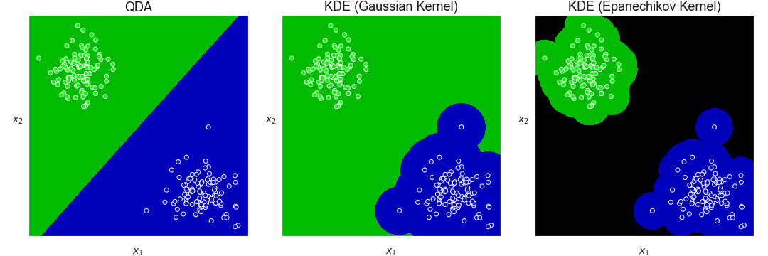

**------------------------------------------------------------------------------------------------------------------------------------------**

**Description :**

# **Comparison QDA and KDE classifications (gaussian pdf, much larger bandwidths)**

2D_KDE_classification.ipynb

2D_KDE_classif_gaussian_2.png

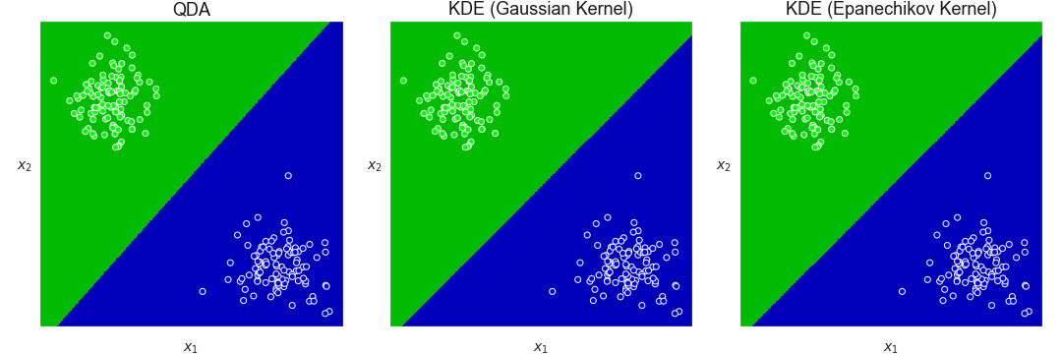

**------------------------------------------------------------------------------------------------------------------------------------------**

**Description :**

# **Comparison QDA and KDE classifications (circles, Epanechikov bandwidth too small)**

2D_KDE_classification.ipynb

2D_KDE_classif_circles_1.png

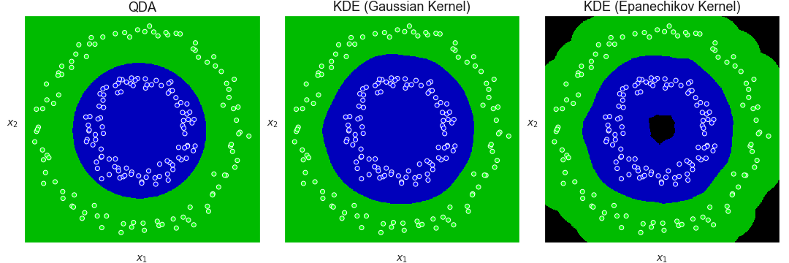

**------------------------------------------------------------------------------------------------------------------------------------------**

**Description :**

# **Comparison QDA and KDE classifications (circles, bandwidths ok)**

2D_KDE_classification.ipynb

2D_KDE_classif_circles_2.png

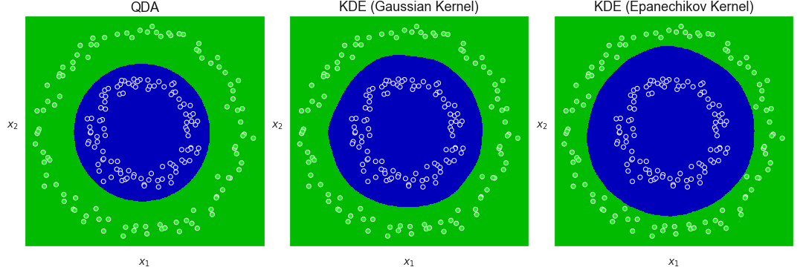

**------------------------------------------------------------------------------------------------------------------------------------------**

**Description :**

# **Comparison QDA and KDE classifications (crescents, Epanechikov bandwidth too small)**

2D_KDE_classification.ipynb

2D_KDE_classif_crescents_1.png

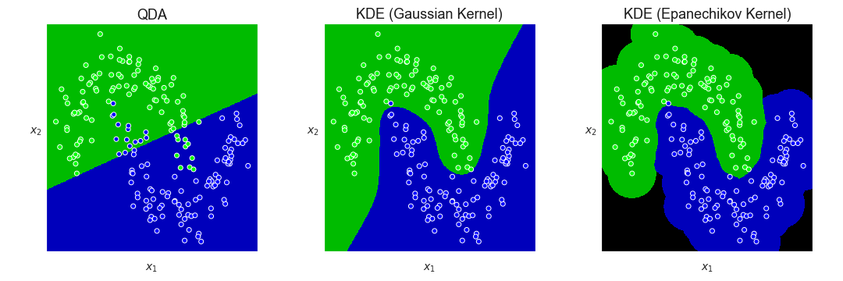

**------------------------------------------------------------------------------------------------------------------------------------------**

**Description :**

# **Comparison QDA and KDE classifications (crescents, bandwidths ok)**

2D_KDE_classification.ipynb

2D_KDE_classif_crescents_2.png

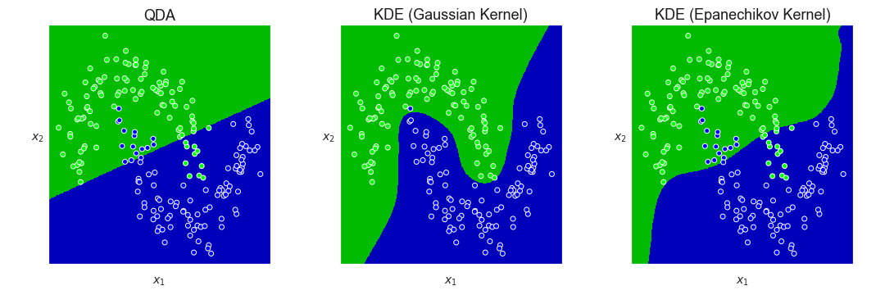

**------------------------------------------------------------------------------------------------------------------------------------------**

**Description :**

# **Comparison QDA and KDE classifications (random distributions, bandwidths ok)**

2D_KDE_classification.ipynb

2D_KDE_classif_random.png

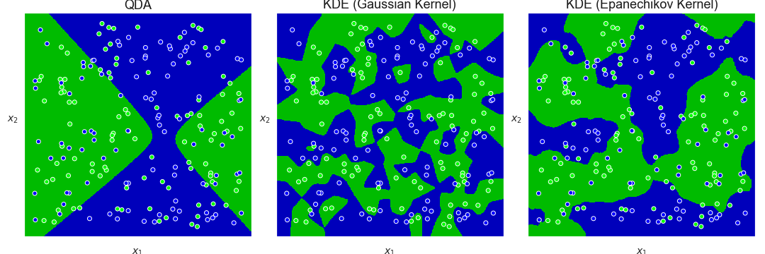

**------------------------------------------------------------------------------------------------------------------------------------------**

**Description :**

# **Reference PDF used in KNN PDF estimations**

PDF_estimation_using_histogram_and_KNN_methods.ipynb

KNN_PDF_estimator_reference.png

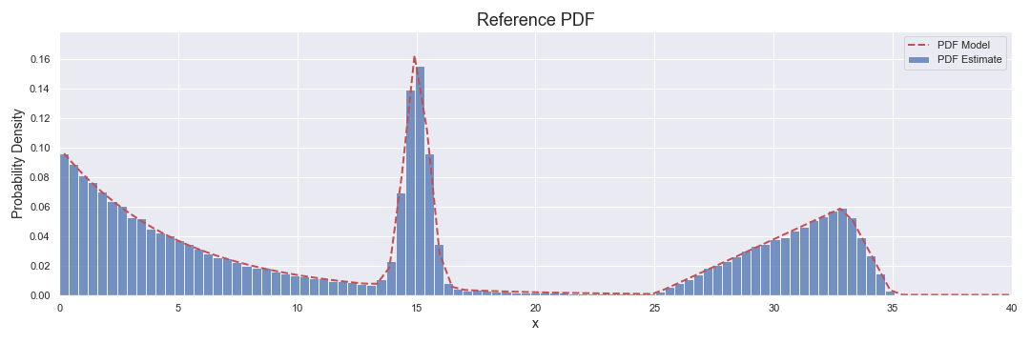

**------------------------------------------------------------------------------------------------------------------------------------------**

**Description :**

# **Effect of varying number of nearest neighbors in KNN PDF estimation (small dataset)**

PDF_estimation_using_histogram_and_KNN_methods.ipynb

KNN_PDF_estimator_variable_NN_small_dataset.png

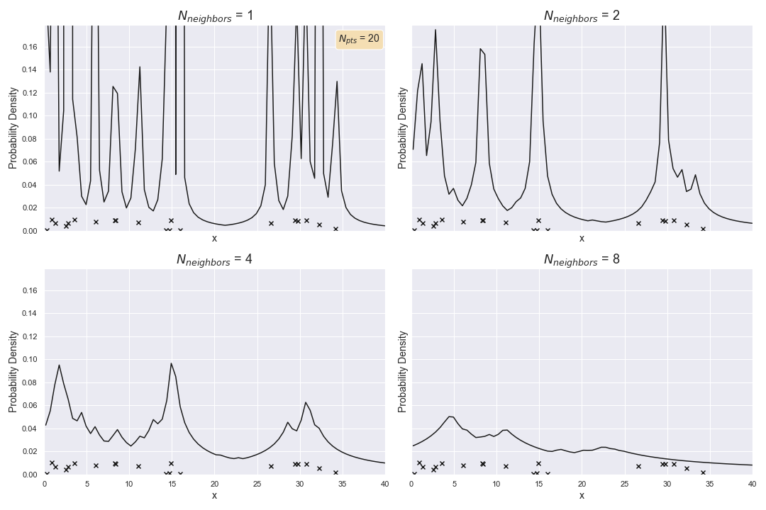

**------------------------------------------------------------------------------------------------------------------------------------------**

**Description :**

# **Effect of varying number of nearest neighbors in KNN PDF estimation (large dataset)**

PDF_estimation_using_histogram_and_KNN_methods.ipynb

KNN_PDF_estimator_variable_NN_large_dataset.png

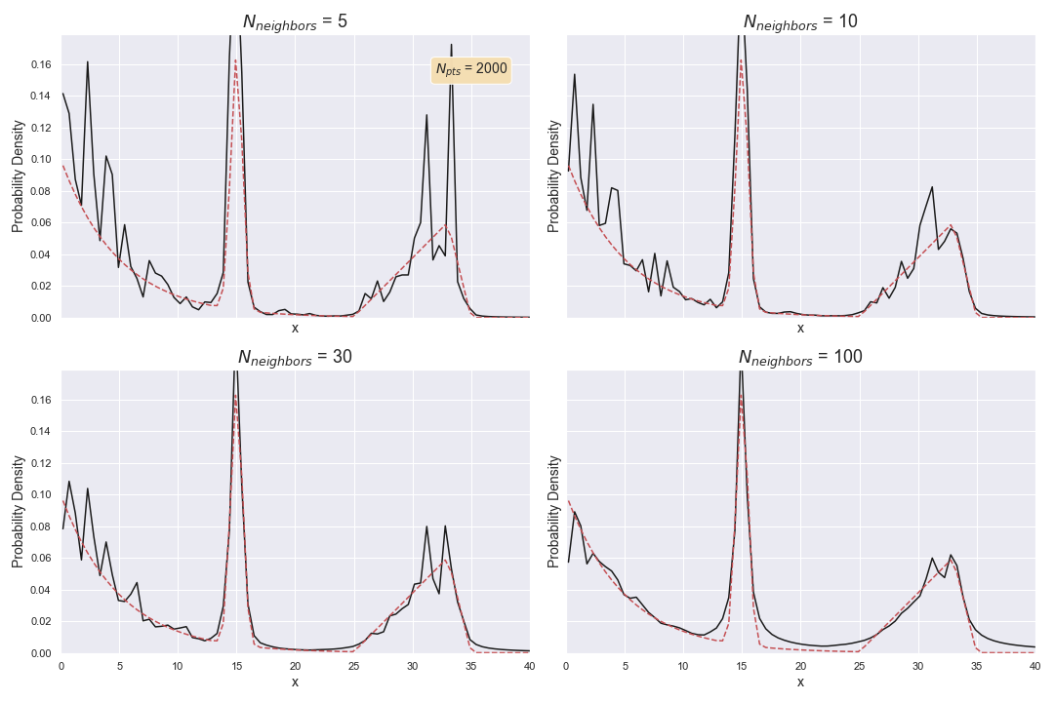

**------------------------------------------------------------------------------------------------------------------------------------------**

**Description :**

# **Effect of dataset size on KNN PDF estimation**

PDF_estimation_using_histogram_and_KNN_methods.ipynb

KNN_PDF_estimator_variable_dataset_size.png

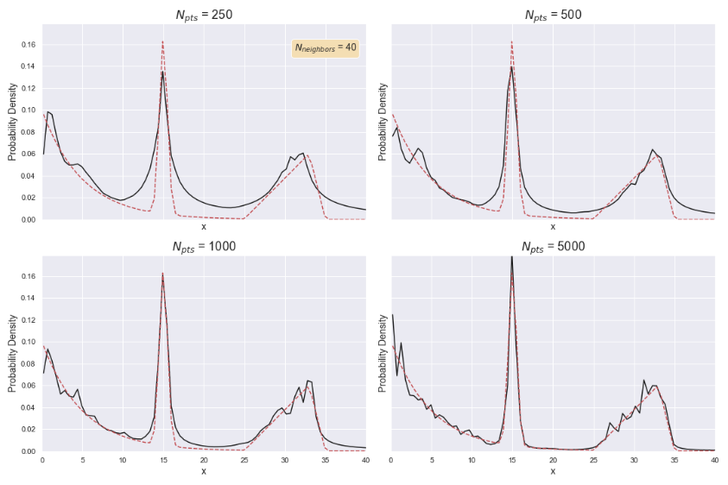

**------------------------------------------------------------------------------------------------------------------------------------------**

**Description :**

# **Comparison of histogram-based and KNN PDF estimation (small dataset)**

PDF_estimation_using_histogram_and_KNN_methods.ipynb

KNN_Histogram_PDF_comparison_small_dataset.png

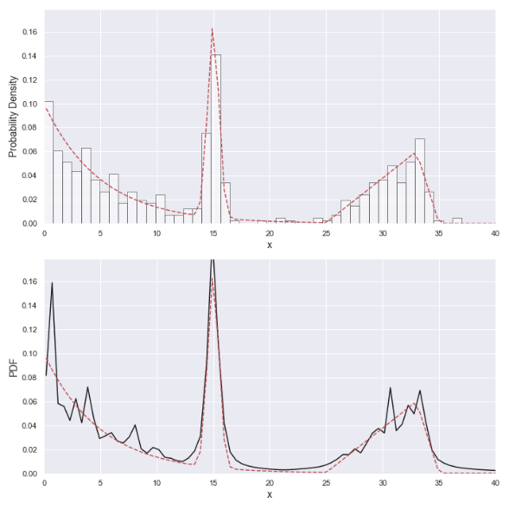

**------------------------------------------------------------------------------------------------------------------------------------------**

**Description :**

# **Comparison of histogram-based and KNN PDF estimation (large dataset)**

PDF_estimation_using_histogram_and_KNN_methods.ipynb

KNN_Histogram_PDF_comparison_large_dataset.png

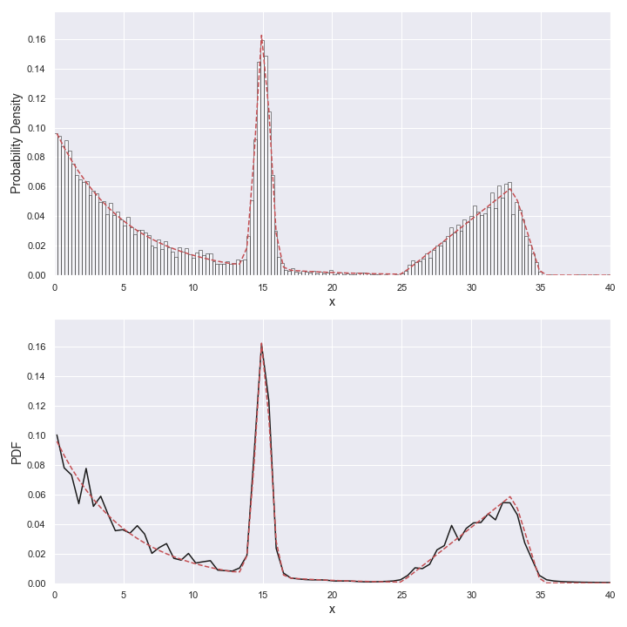

**------------------------------------------------------------------------------------------------------------------------------------------**

**Description :**

# **Comparison of histogram-based and KNN PDF estimation (large dataset)**

Nearest_Neighbor_classification_versus_Voronoi_diagram.ipynb

Nearest_neighbor_classification_and_Voronoi_diagram_1.png

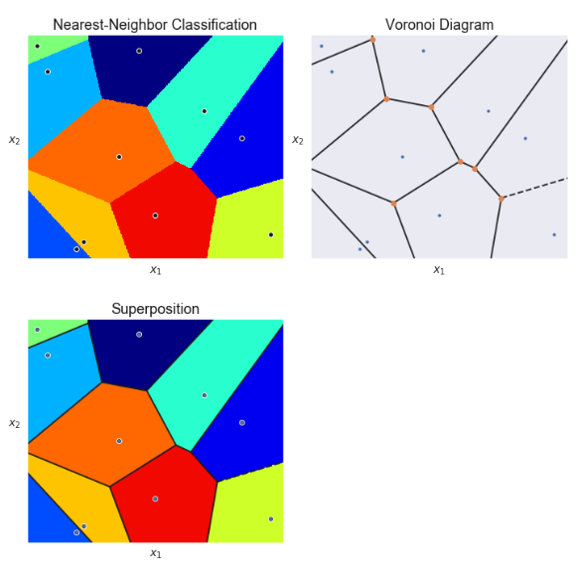

**------------------------------------------------------------------------------------------------------------------------------------------**

**Description :**

# **Comparison of histogram-based and KNN PDF estimation (large dataset)**

Nearest_Neighbor_classification_versus_Voronoi_diagram.ipynb

Nearest_neighbor_classification_and_Voronoi_diagram_2.png

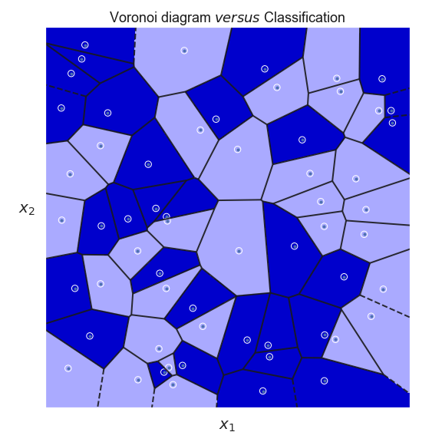

**------------------------------------------------------------------------------------------------------------------------------------------**

**Description :**

# **Comparison of QDA and KNN classifications (concentric circles, easy case)**

2D_Nearest_Neighbors_classification.ipynb

2D_KNN_classif_circles_1.png

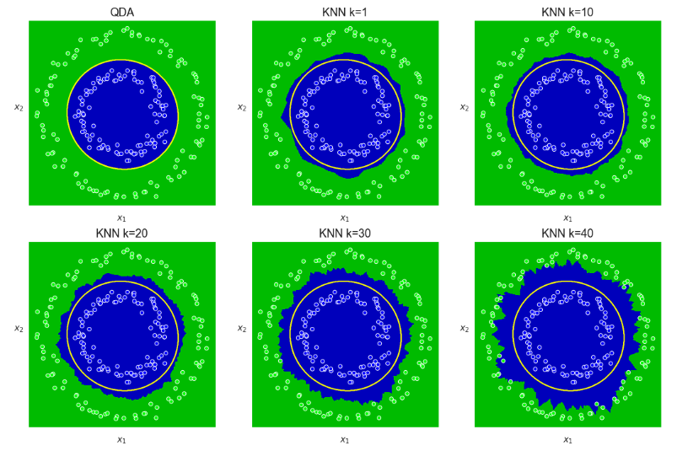

**------------------------------------------------------------------------------------------------------------------------------------------**

**Description :**

# **Comparison of QDA and KNN classifications (concentric circles, harder case)**

2D_Nearest_Neighbors_classification.ipynb

2D_KNN_classif_circles_2.png

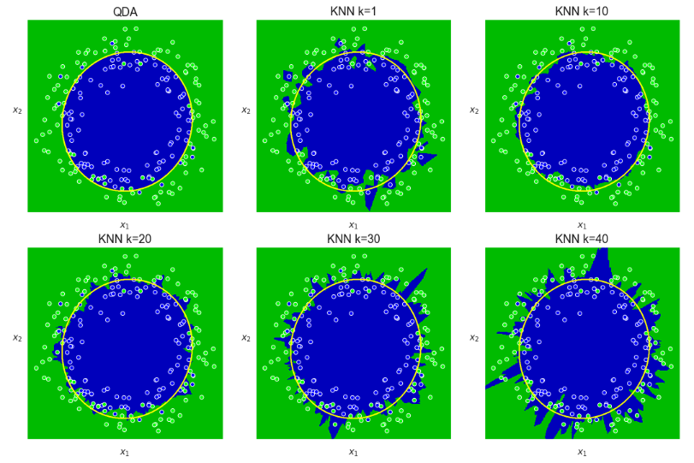

**------------------------------------------------------------------------------------------------------------------------------------------**

**Description :**

# **Comparison of QDA and KNN classifications (concentric circles, harder case with more data)**

2D_Nearest_Neighbors_classification.ipynb

2D_KNN_classif_circles_3.png

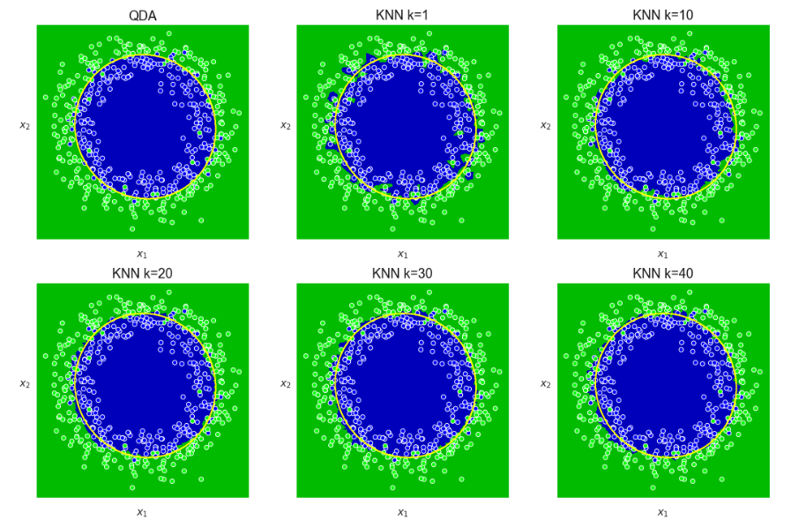

**------------------------------------------------------------------------------------------------------------------------------------------**

**Description :**

# **Comparison of QDA and KNN classifications (crescents, a much harder case)**

2D_Nearest_Neighbors_classification.ipynb

2D_KNN_classif_crescents.png

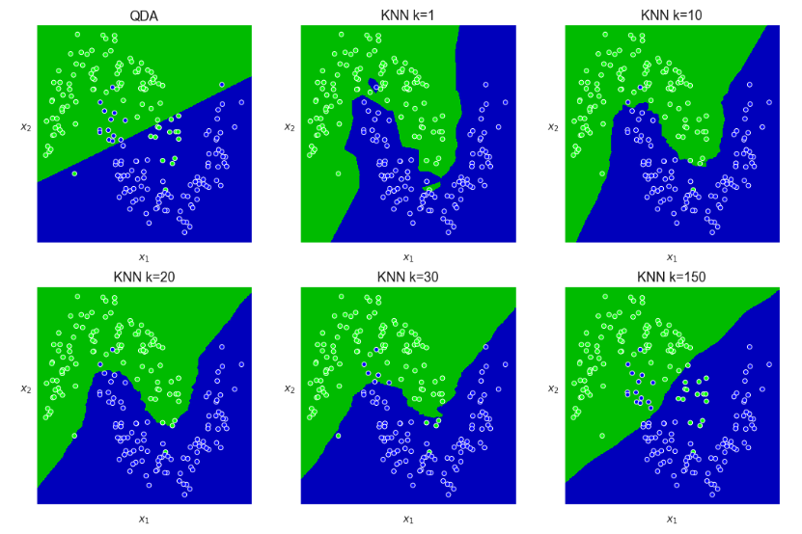

**------------------------------------------------------------------------------------------------------------------------------------------**

**Description :**

# **3D Voronoi diagram**

<http://www.qhull.org/html/normal_voronoi_knauss_oesterle.jpg> (creative Commons)

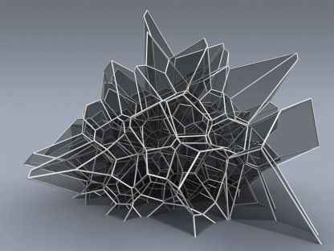

**------------------------------------------------------------------------------------------------------------------------------------------**

**Description :**

# **3D Voronoi diagram**

https://i.stack.imgur.com/O3pws.jpg (creative Commons)

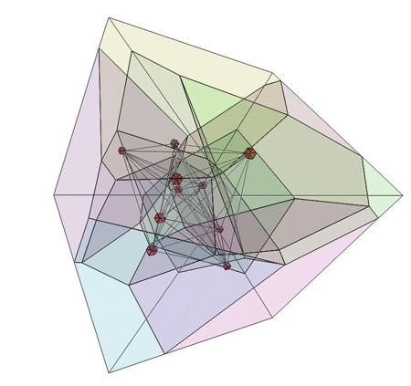

**------------------------------------------------------------------------------------------------------------------------------------------**

**Description :**

# **Individual 3D representations of Minkowski distance**

Compare_Minkowsi_distances_in_3D.ipynb

Minkowski distance_1.png

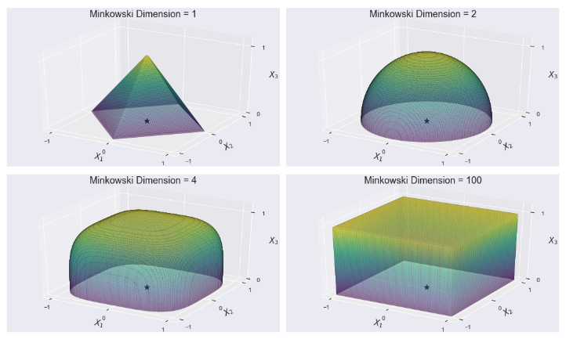

**------------------------------------------------------------------------------------------------------------------------------------------**

**Description :**

# **Superposed 3D representations of Minkowski distance**

Compare_Minkowsi_distances_in_3D.ipynb

Minkowski distance_2.png

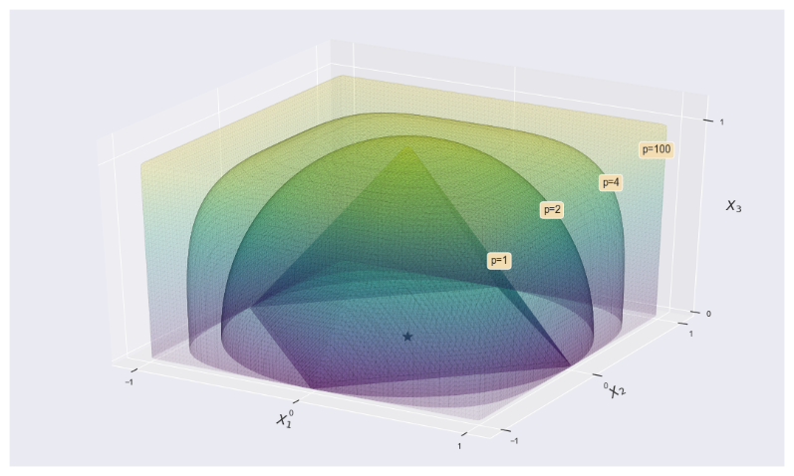

**------------------------------------------------------------------------------------------------------------------------------------------**

**Description :**

# **2D Nearest-Neighbor classification using Wilson edition and Hart distillation**

Hart_Wilson_neighbors_removal.ipynb

2D_NN_with Hart_Wilson_classif_circles_1.png

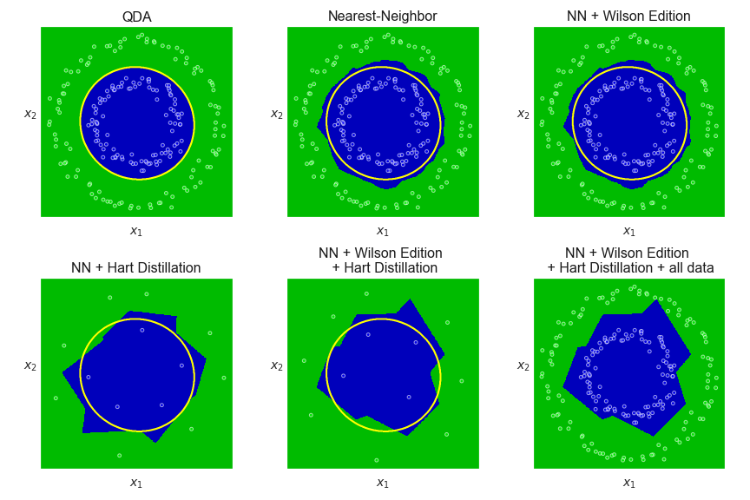

**------------------------------------------------------------------------------------------------------------------------------------------**

**Description :**

# **2D Nearest-Neighbor classification using Wilson edition and Hart distillation**

Hart_Wilson_neighbors_removal.ipynb

2D_NN_with Hart_Wilson_classif_circles_2.png

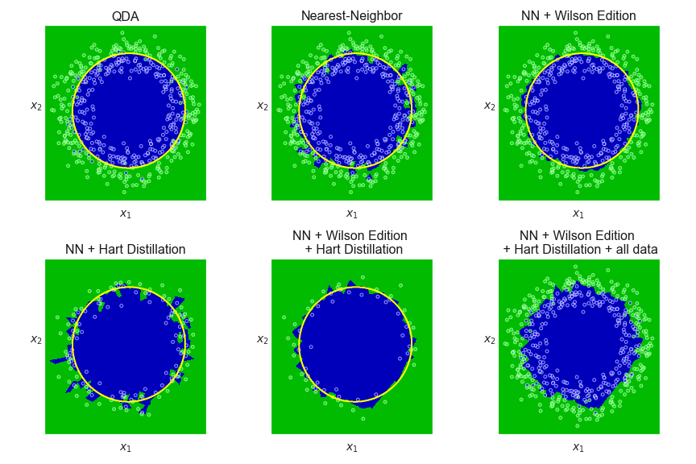

**------------------------------------------------------------------------------------------------------------------------------------------**

**Description :**

# **2D Nearest-Neighbor classification using Wilson edition and Hart distillation**

Hart_Wilson_neighbors_removal.ipynb

2D_NN_with Hart_Wilson_classif_crescents.png

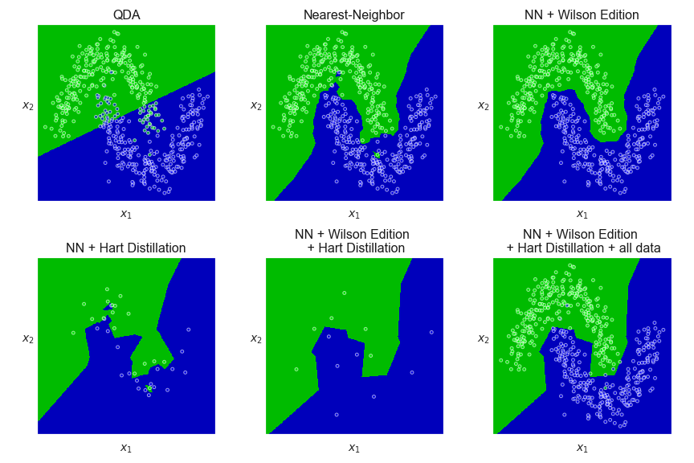

**------------------------------------------------------------------------------------------------------------------------------------------**

**Description :**

# **2D classifications with SVM with RBF**

6.1_SVM_with_RBF_2D_classifications.ipynb

6.1.1_SVM_classification_crescents.png

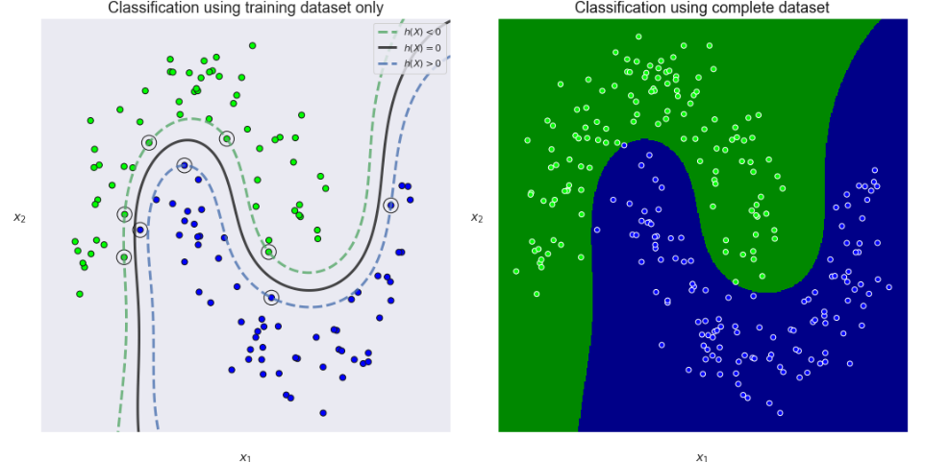

**------------------------------------------------------------------------------------------------------------------------------------------**

**Description :**

# **2D classifications with SVM with RBF**

6.1_SVM_with_RBF_2D_classifications.ipynb

6.1.2_SVM_classification_separated_circles.png

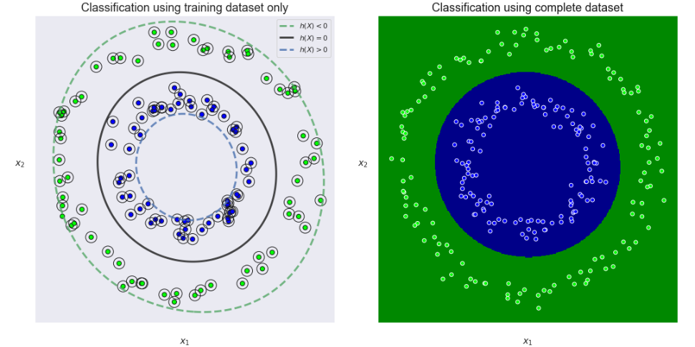

**------------------------------------------------------------------------------------------------------------------------------------------**

**Description :**

# **2D classifications with SVM with RBF**

6.1_SVM_with_RBF_2D_classifications.ipynb

6.1.3_SVM_classification_overlapping_circles.png

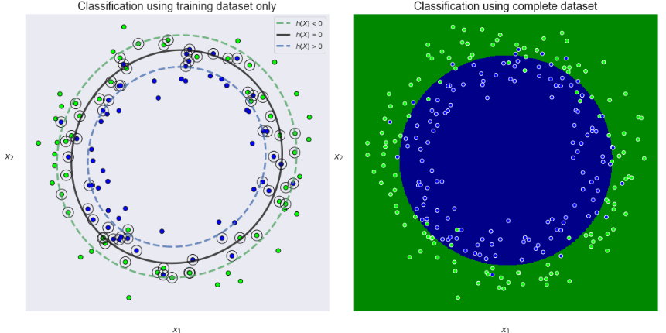

**------------------------------------------------------------------------------------------------------------------------------------------**

**Description :**

# **2D classifications with SVM with RBF**

6.1_SVM_with_RBF_2D_classifications.ipynb

6.1.4_SVM_classification_cross.png

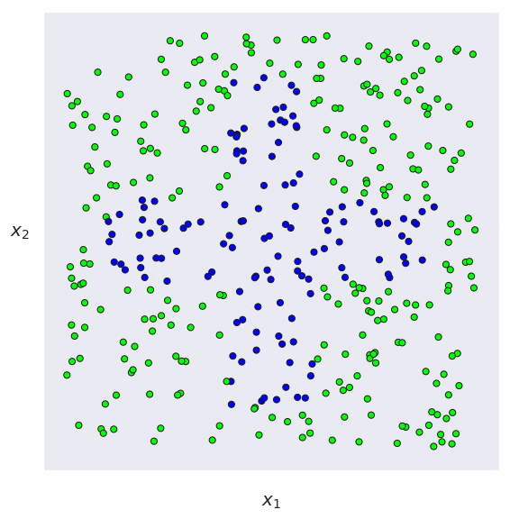

**------------------------------------------------------------------------------------------------------------------------------------------**

**Description :**

# **2D classifications with SVM with RBF**

6.1_SVM_with_RBF_2D_classifications.ipynb

6.1.5_SVM_classification_cross.png

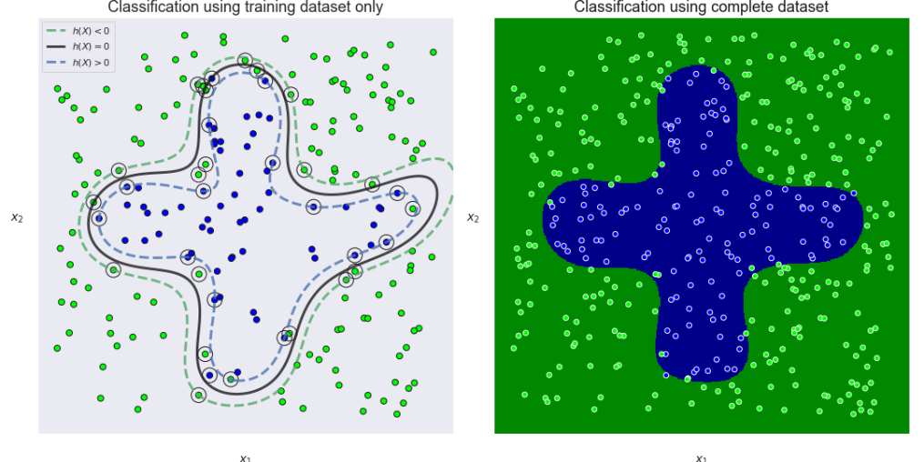

**------------------------------------------------------------------------------------------------------------------------------------------**

**Description :**

# **2D classifications with linear, poly and RBF SVM**

6.2_SVM_linear_poly_RBF_classifications_with_same_2D_dataset.ipynb

6.2.1_Overlapping_blobs_dataset.png

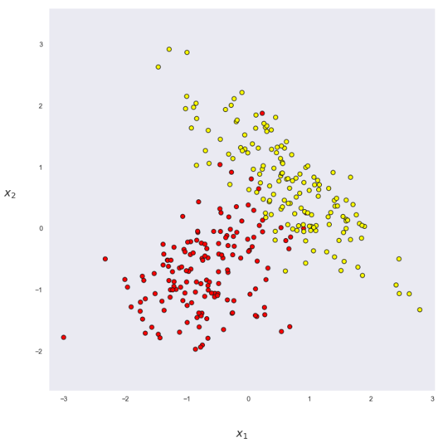

**------------------------------------------------------------------------------------------------------------------------------------------**

**Description :**

# **2D classifications with linear, poly and RBF SVM**

6.2_SVM_linear_poly_RBF_classifications_with_same_2D_dataset.ipynb

6.2.2_SVM_linear_classification_of_overlapping_blobs.png

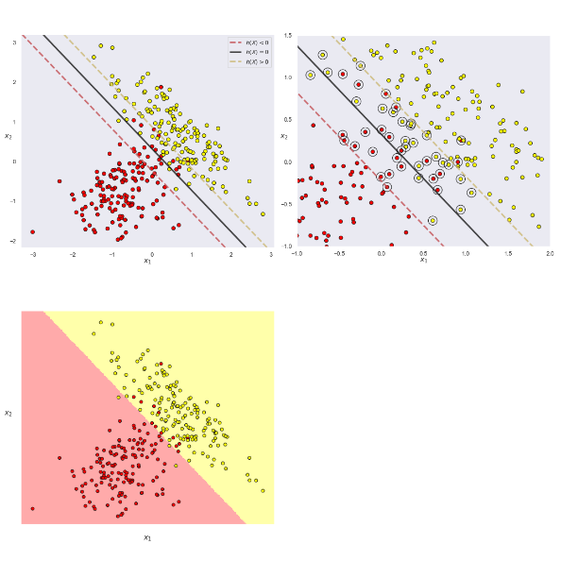

**------------------------------------------------------------------------------------------------------------------------------------------**

**Description :**

# **2D classifications with linear, poly and RBF SVM**

6.2_SVM_linear_poly_RBF_classifications_with_same_2D_dataset.ipynb

6.2.3_SVM_polynomial_classification_of_overlapping_blobs.png

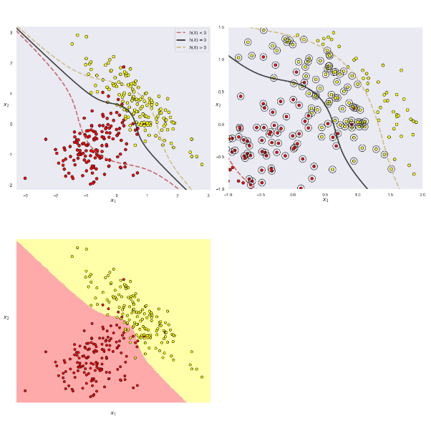

**------------------------------------------------------------------------------------------------------------------------------------------**

**Description :**

# **2D classifications with linear, poly and RBF SVM**

6.2_SVM_linear_poly_RBF_classifications_with_same_2D_dataset.ipynb

6.2.4_SVM_RBF_classification_of_overlapping_blobs.png

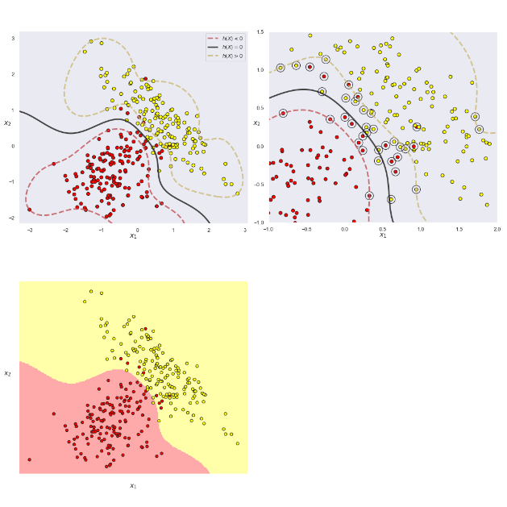

**------------------------------------------------------------------------------------------------------------------------------------------**

**Description :**

# **2D classifications with linear, poly and RBF SVM**

6.2_SVM_linear_poly_RBF_classifications_with_same_2D_dataset.ipynb

6.2.5_SVM_RBF_classification_of_overlapping_blobs_large_gamma.png

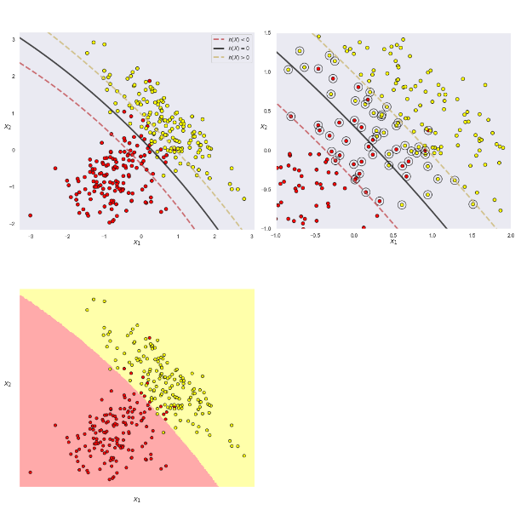

**------------------------------------------------------------------------------------------------------------------------------------------**

**Description :**

# **2D classifications with linear, poly and RBF SVM**

6.2_SVM_linear_poly_RBF_classifications_with_same_2D_dataset.ipynb

6.2.6_SVM_RBF_classification_of_overlapping_blobs_small_gamma.png

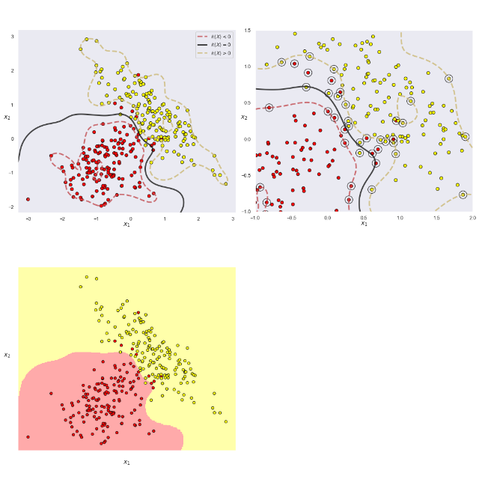

**------------------------------------------------------------------------------------------------------------------------------------------**

**Description :**

# **1-D Regression with MLP**

7.1_MLP_regression.ipynb

7.1.1_Original_data.png.png

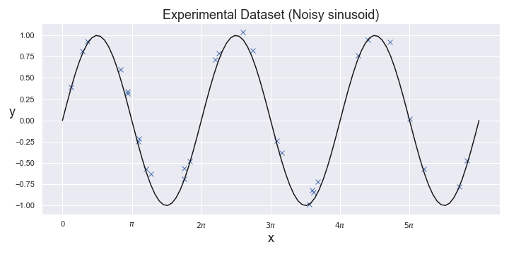

**------------------------------------------------------------------------------------------------------------------------------------------**

**Description :**

# **1-D Regression with MLP**

7.1_MLP_regression.ipynb

7.1.2_Several_MLP_fits.png

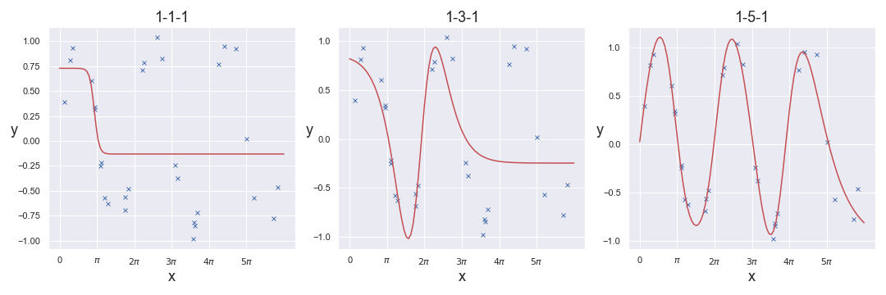

**------------------------------------------------------------------------------------------------------------------------------------------**

**Description :**

# **1-D Regression with MLP**

7.1_MLP_regression.ipynb

7.1.3_MLP_fit_error_versus_number_of neurons.png

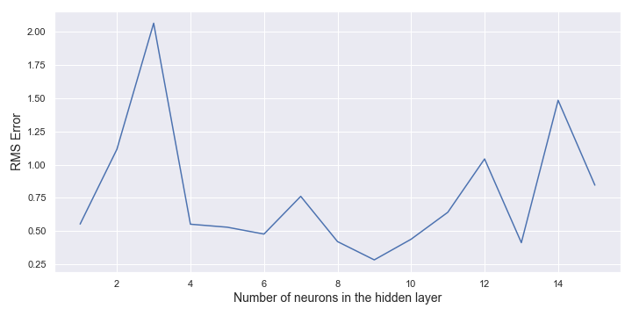

**------------------------------------------------------------------------------------------------------------------------------------------**

**Description :**

# **1-D Regression with MLP**

7.1_MLP_regression.ipynb

7.1.4_Best_MLP_fit.png

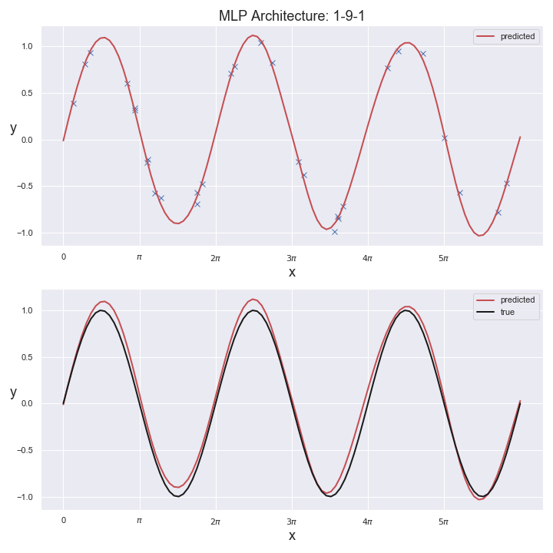

**------------------------------------------------------------------------------------------------------------------------------------------**

**Description :**

# **2D classifications with MLP**

7.2_Examples_of_MLP_classifications_with_different_optimizers.ipynb

7.2.1_Overlapping_blobs_dataset.png

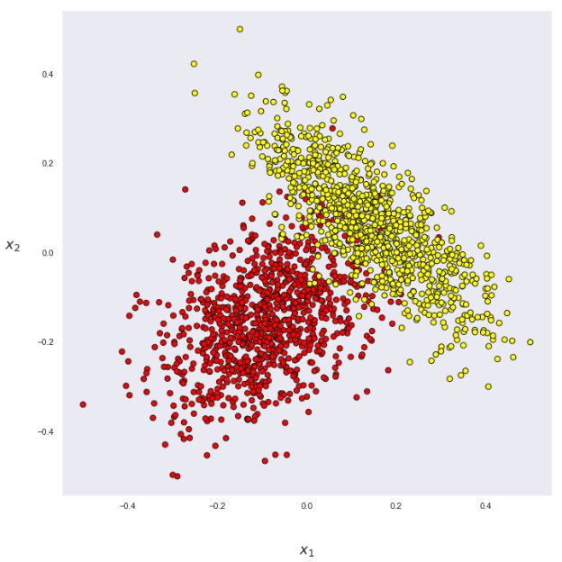

**------------------------------------------------------------------------------------------------------------------------------------------**

**Description :**

# **2D classifications with MLP**

7.2_Examples_of_MLP_classifications_with_different_optimizers.ipynb

7.2.2_MLP_Training_loss_curves.png

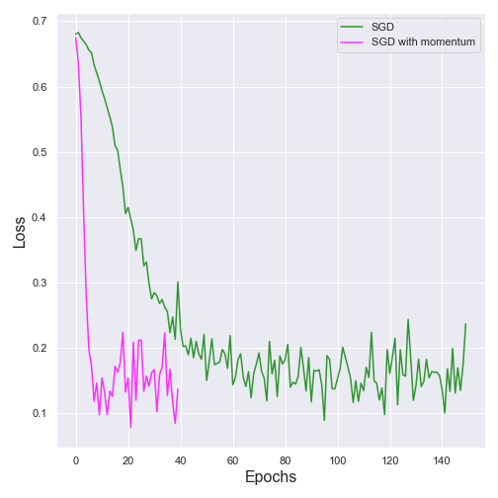

**------------------------------------------------------------------------------------------------------------------------------------------**

**Description :**

# **2D classifications with MLP**

7.2_Examples_of_MLP_classifications_with_different_optimizers.ipynb

7.2.3_MLP_training_test_loss_curves_comparison.png

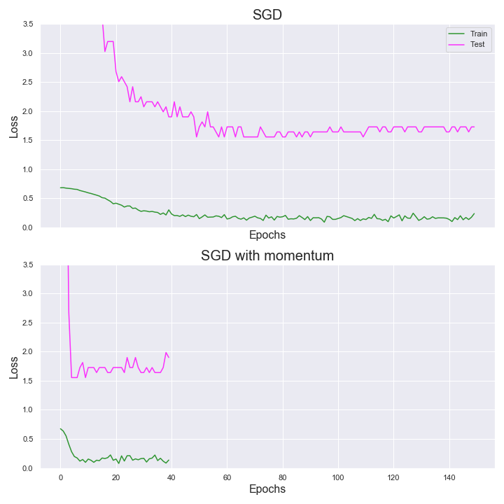

**------------------------------------------------------------------------------------------------------------------------------------------**

**Description :**

# **2D classifications with MLP**

7.2_Examples_of_MLP_classifications_with_different_optimizers.ipynb

7.2.4_MLP_training_test_accuracy_curves_comparison.png

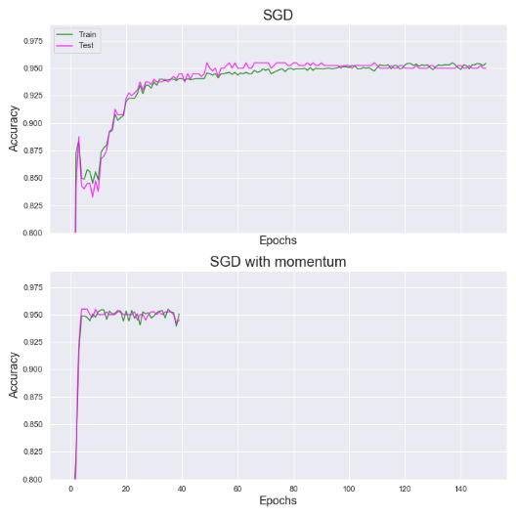

**------------------------------------------------------------------------------------------------------------------------------------------**

**Description :**

# **2D classifications with MLP**

7.2_Examples_of_MLP_classifications_with_different_optimizers.ipynb

7.2.5_MLP_Neuron_weight_trajectory.png

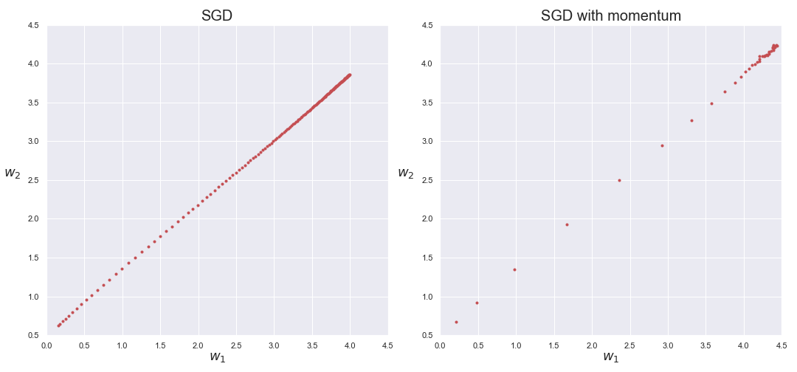

**------------------------------------------------------------------------------------------------------------------------------------------**

**Description :**

# **2D classifications with MLP**

7.2_Examples_of_MLP_classifications_with_different_optimizers.ipynb

7.2.6_MLP_classification_comparison.png

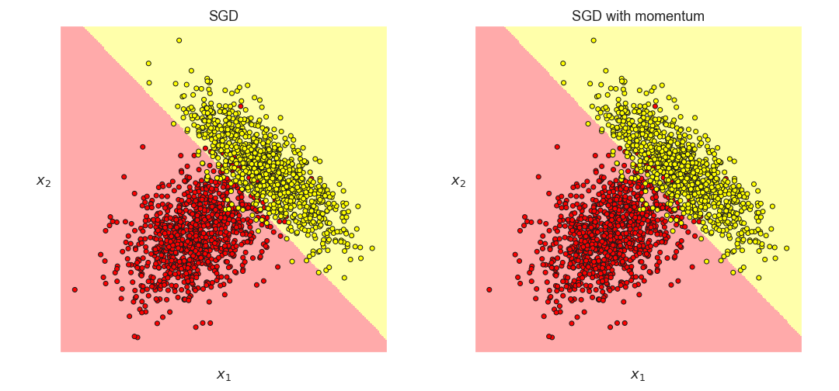

**------------------------------------------------------------------------------------------------------------------------------------------**

**Description :**

# **2D classifications with AdaBoost**

12.1_AdaBoost_2D_Classification.ipynb

12.1.1_dataset_to_classity.png

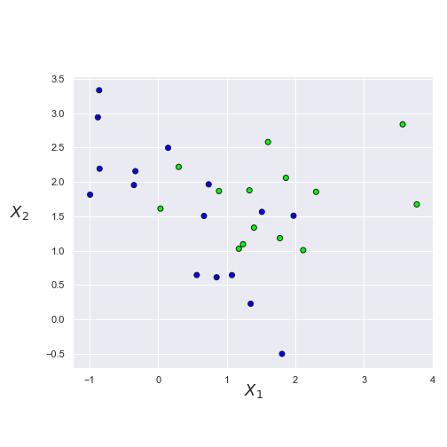

**------------------------------------------------------------------------------------------------------------------------------------------**

**Description :**

**2D classifications with AdaBoost**

12.1_AdaBoost_2D_Classification.ipynb

12.1.2_weak_learner_errors_and_alpha_factors_lambda_0.3.png

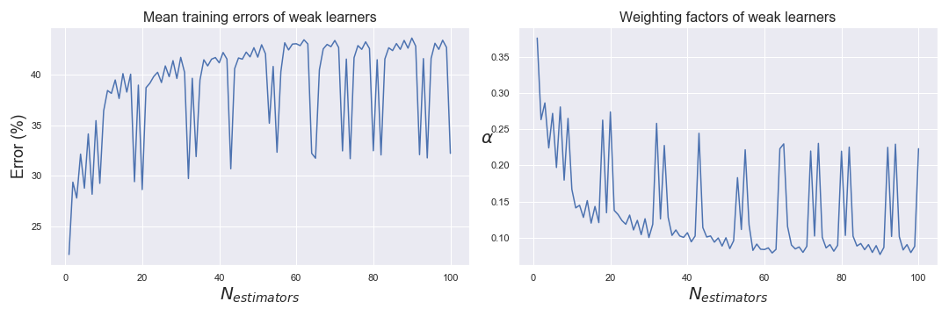

**------------------------------------------------------------------------------------------------------------------------------------------**

**Description :**

**2D classifications with AdaBoost**

12.1_AdaBoost_2D_Classification.ipynb

12.1.3_weak_learner_scores_lambda_0.3.png

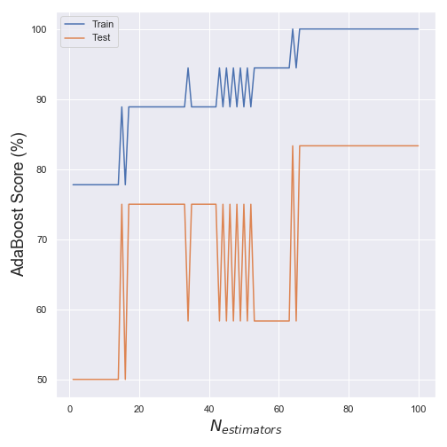

**------------------------------------------------------------------------------------------------------------------------------------------**

**Description :**

**2D classifications with AdaBoost**

12.1_AdaBoost_2D_Classification.ipynb

12.1.4_weak_learners_vs_AdaBoost_scores_lambda_0.3.png

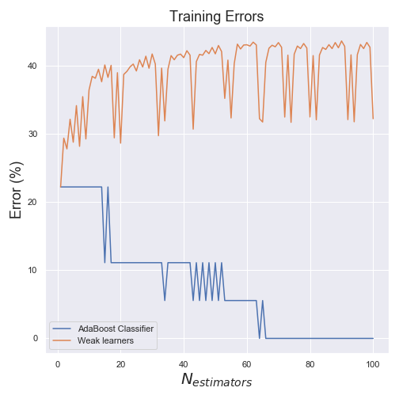

**------------------------------------------------------------------------------------------------------------------------------------------**

**Description :**

**2D classifications with AdaBoost**

12.1_AdaBoost_2D_Classification.ipynb

12.1.5_weak_learner_errors_vs_AdaBoost_scores_lambda_0.1.png

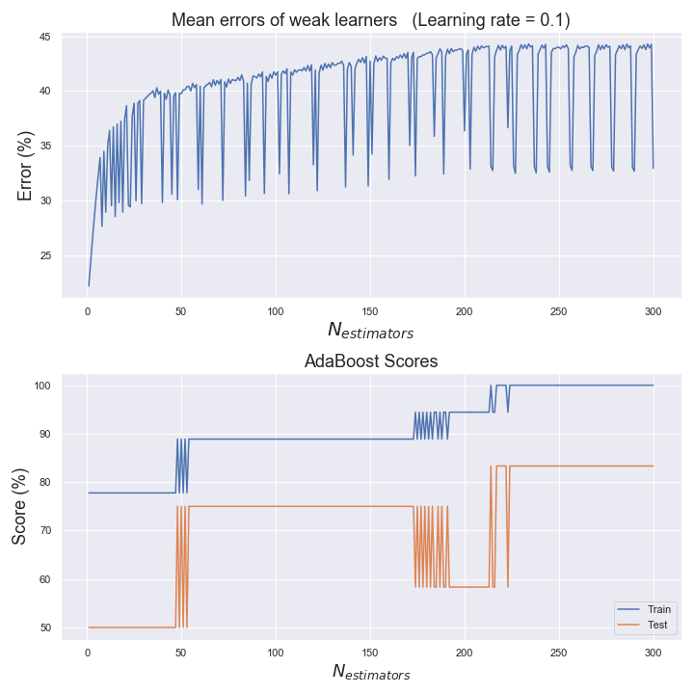

**------------------------------------------------------------------------------------------------------------------------------------------**

**Description :**

**2D classifications with AdaBoost**

12.1_AdaBoost_2D_Classification.ipynb

12.1.6_weak_learner_errors_vs_AdaBoost_scores_lambda_1.0.png

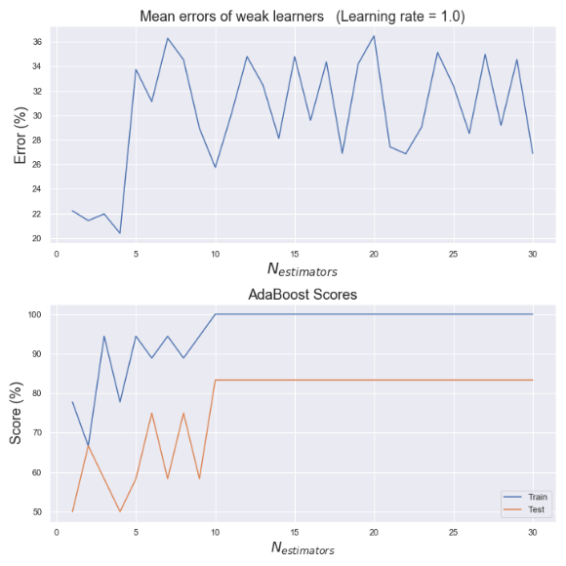

**------------------------------------------------------------------------------------------------------------------------------------------**

**Description :**

**2D classifications with AdaBoost**

12.1_AdaBoost_2D_Classification.ipynb

12.1.7_weak_learner_and_AdaBoost_decision_boundaries_lambda_1.0.png

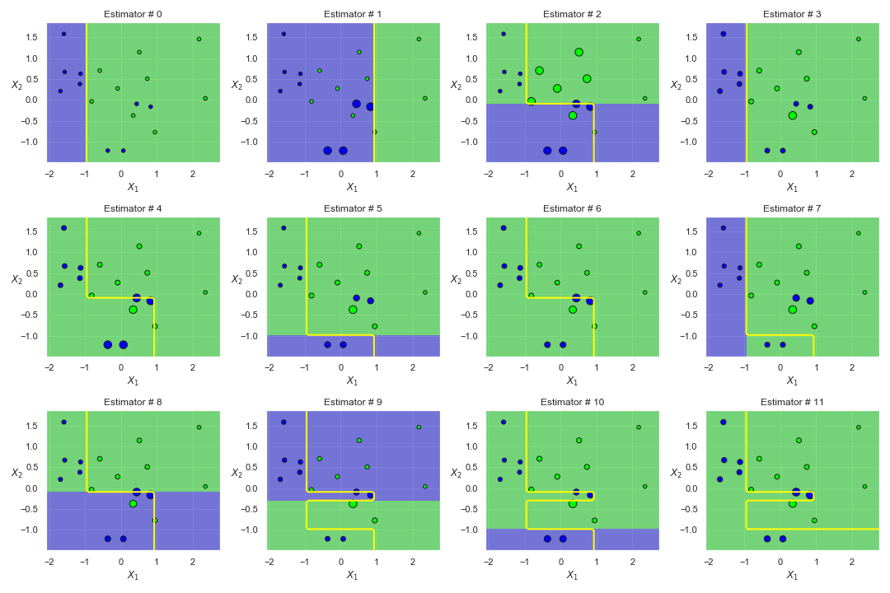

**------------------------------------------------------------------------------------------------------------------------------------------**

**Description :**

# **2D classifications with AdaBoost**

12.1_AdaBoost_2D_Classification.ipynb

12.1.8_AdaBoost_final_decision_boundaries_lambda_1.0.png

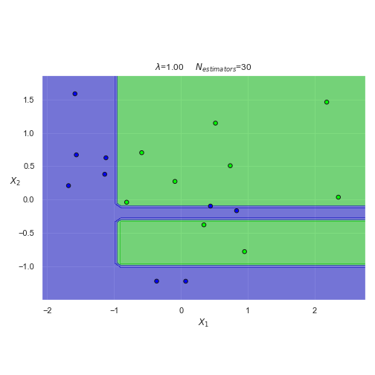

**------------------------------------------------------------------------------------------------------------------------------------------**

**Description :**

**2D classifications with AdaBoost**

12.1_AdaBoost_2D_Classification.ipynb

12.1.9_AdaBoost_decision_boundaries_various_lambda_and_N_estimators.png

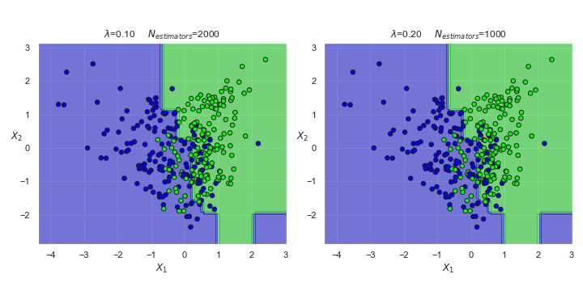

**------------------------------------------------------------------------------------------------------------------------------------------**

**Description :**

**PCA image reconstructions**

13.1_Generate_image_reconstructions_using_PCA.ipynb

13.1.1_Examples_from_MNIST_dataset.png

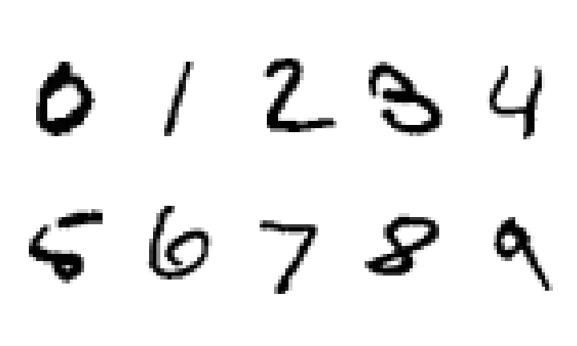

**------------------------------------------------------------------------------------------------------------------------------------------**

**Description :**

**PCA image reconstructions**

13.1_Generate_image_reconstructions_using_PCA.ipynb

13.1.2_MNIST_scree_plot.png

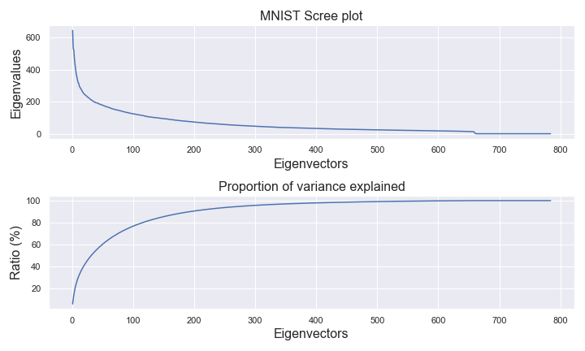

**------------------------------------------------------------------------------------------------------------------------------------------**

**Description :**

**PCA image reconstructions**

13.1_Generate_image_reconstructions_using_PCA.ipynb

13.1.3_Examples_of_eigenvectors.png

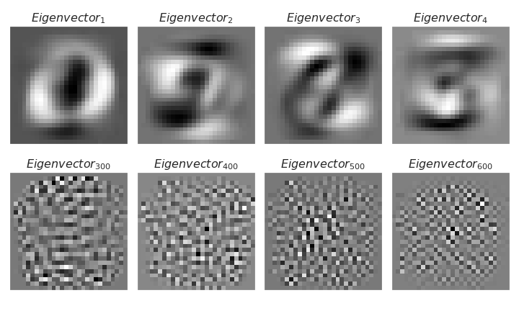

**------------------------------------------------------------------------------------------------------------------------------------------**

**Description :**

**PCA image reconstructions**

13.1_Generate_image_reconstructions_using_PCA.ipynb

13.1.4_2D_PCA_space_for_MNIST.png

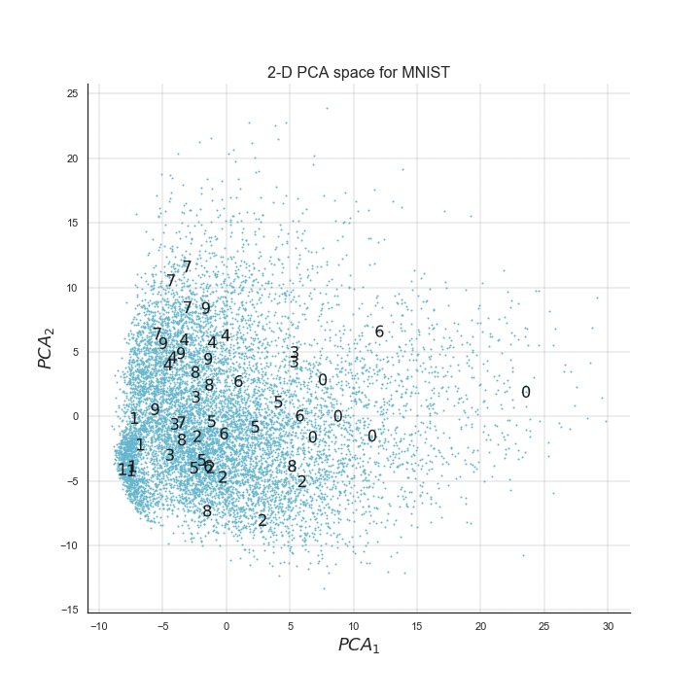

**------------------------------------------------------------------------------------------------------------------------------------------**

**Description :**

**PCA image reconstructions**

13.1_Generate_image_reconstructions_using_PCA.ipynb

13.1.5_2D_PCA_space_for_MNIST_with_images.png

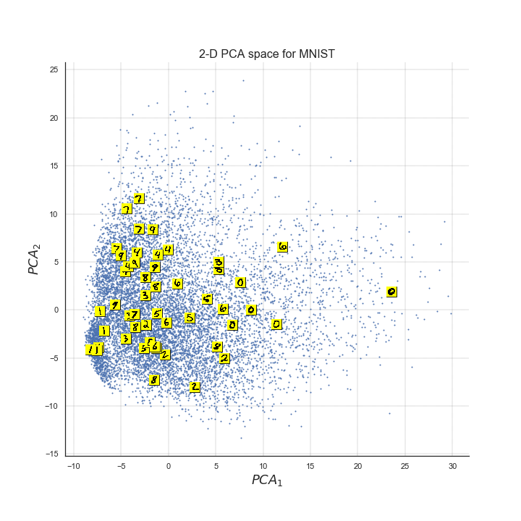

**------------------------------------------------------------------------------------------------------------------------------------------**

**Description :**

**PCA image reconstructions**

13.1_Generate_image_reconstructions_using_PCA.ipynb

13.1.6_confusion_matrix.png

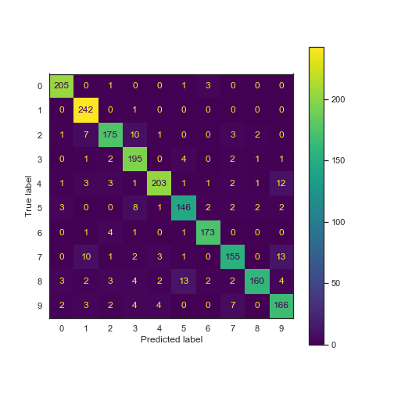

**------------------------------------------------------------------------------------------------------------------------------------------**

**Description :**

**PCA image reconstructions**

13.1_Generate_image_reconstructions_using_PCA.ipynb

13.1.7_Examples_image_reconstructions_7_and_9.png

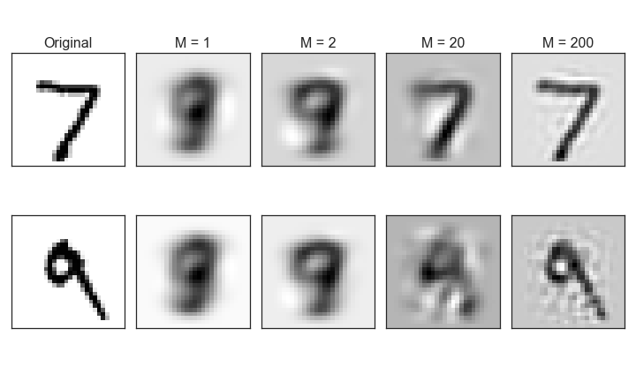

**------------------------------------------------------------------------------------------------------------------------------------------**

**Description :**

**PCA image reconstructions**

13.1_Generate_image_reconstructions_using_PCA.ipynb

13.1.8_Examples_image_reconstructions_1_and_7.png

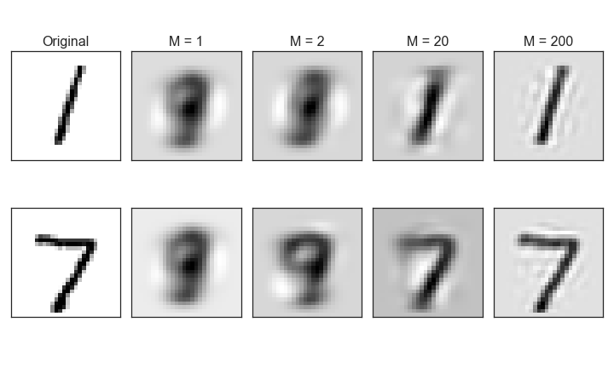

**------------------------------------------------------------------------------------------------------------------------------------------**

**Description :**

**Find optimal number of PCA components in a scree plot**

13.2_Finding _the_optimal_number_of_PCA_components.ipynb

13.2.1_Examples_from_Olivetti_face_dataset.png

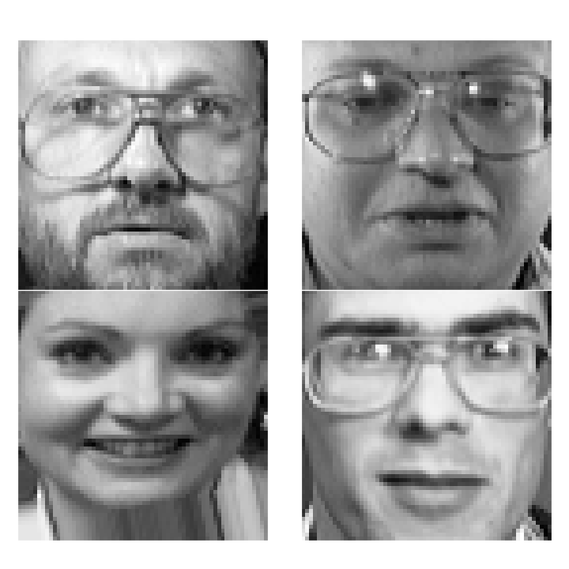

**------------------------------------------------------------------------------------------------------------------------------------------**

**Description :**

**Find optimal number of PCA components in a scree plot**

13.2_Finding _the_optimal_number_of_PCA_components.ipynb

13.2.2_Scree_plot_and_reconstruction_errors.png

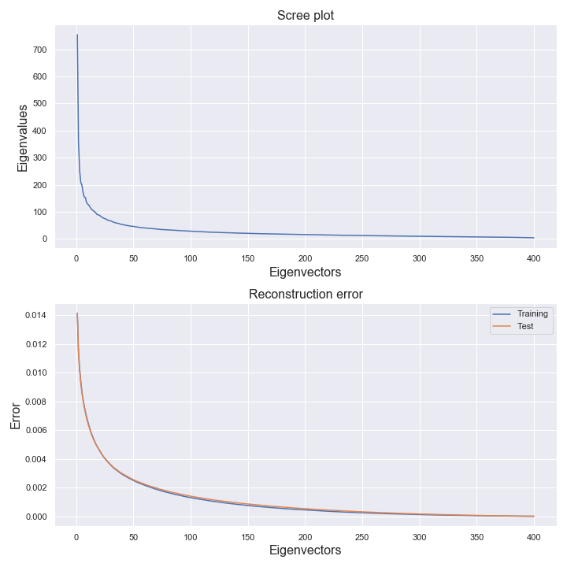

**------------------------------------------------------------------------------------------------------------------------------------------**

**Description :**

**Find optimal number of PCA components in a scree plot**

13.2_Finding _the_optimal_number_of_PCA_components.ipynb

13.2.3_Zoom_on_reconstruction_errors.png

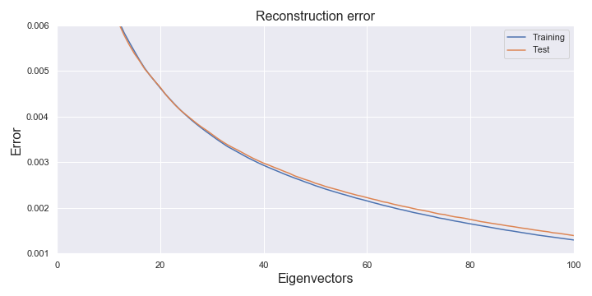

**------------------------------------------------------------------------------------------------------------------------------------------**

**Description :**

**Find optimal number of PCA components in a scree plot**

13.2_Finding _the_optimal_number_of_PCA_components.ipynb

13.2.4_Optimal_number_of_components_to_keep.png

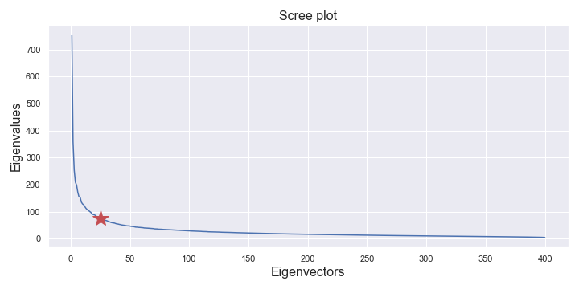

**------------------------------------------------------------------------------------------------------------------------------------------**

**Description :**

**Data whitening in step by step**

13.3_Data_whitening_example.ipynb

13.3.1_original_data.png

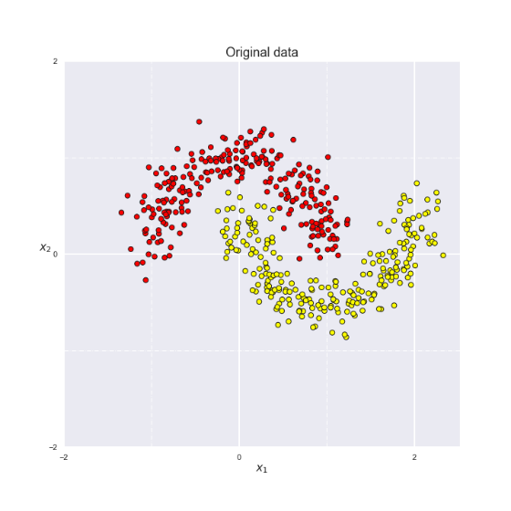

**------------------------------------------------------------------------------------------------------------------------------------------**

**Description :**

**Data whitening in step by step**

13.3_Data_whitening_example.ipynb

13.3.2_normalised_data.png

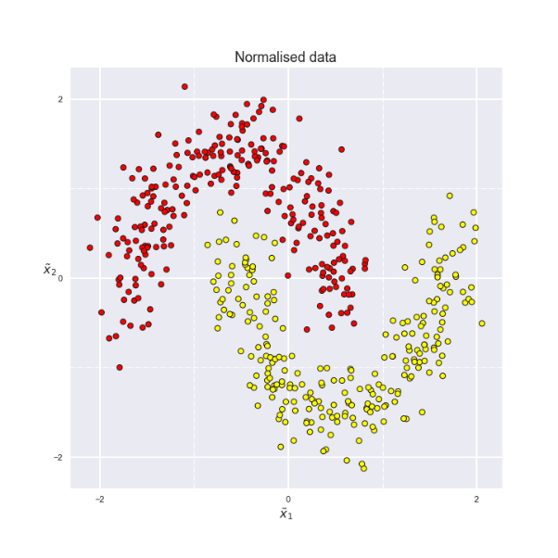

**------------------------------------------------------------------------------------------------------------------------------------------**

**Description :**

**Data whitening in step by step**

13.3_Data_whitening_example.ipynb

13.3.3_principal_components.png

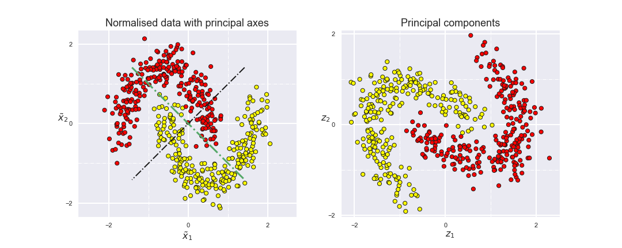

**------------------------------------------------------------------------------------------------------------------------------------------**

**Description :**

**Data whitening in step by step**

13.3_Data_whitening_example.ipynb

13.3.4_normalised_principal_components.png

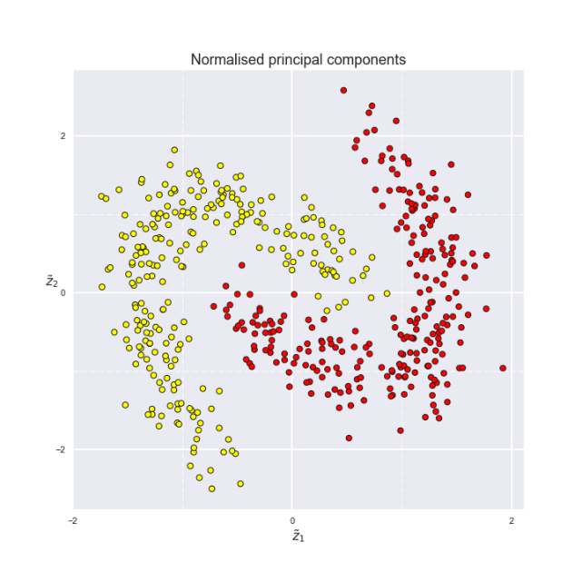

**------------------------------------------------------------------------------------------------------------------------------------------**

**Description :**

**Data whitening in step by step**

13.3_Data_whitening_example.ipynb

13.3.5_whitened_data.png

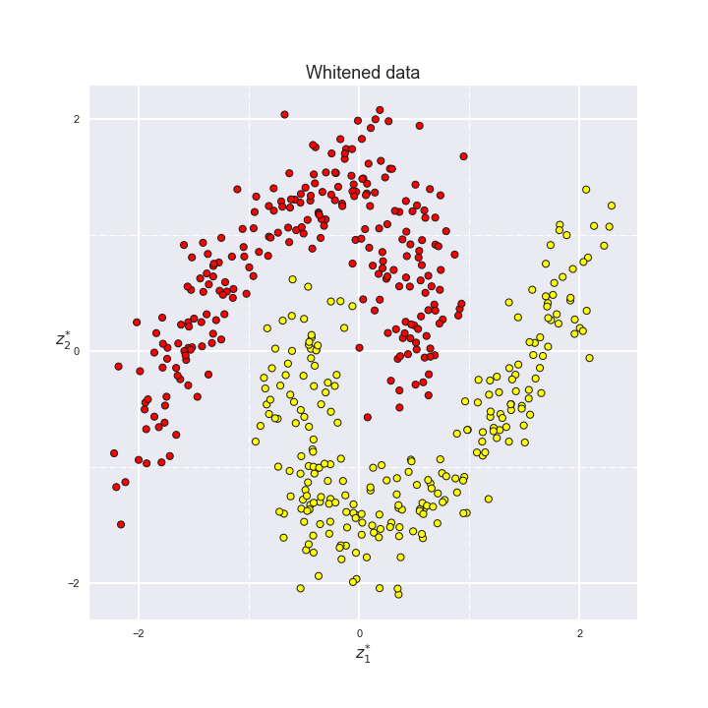

**------------------------------------------------------------------------------------------------------------------------------------------**

**Description :**

**Data whitening in step by step**

13.3_Data_whitening_example.ipynb

13.3.6_data_whitening_comparison.png

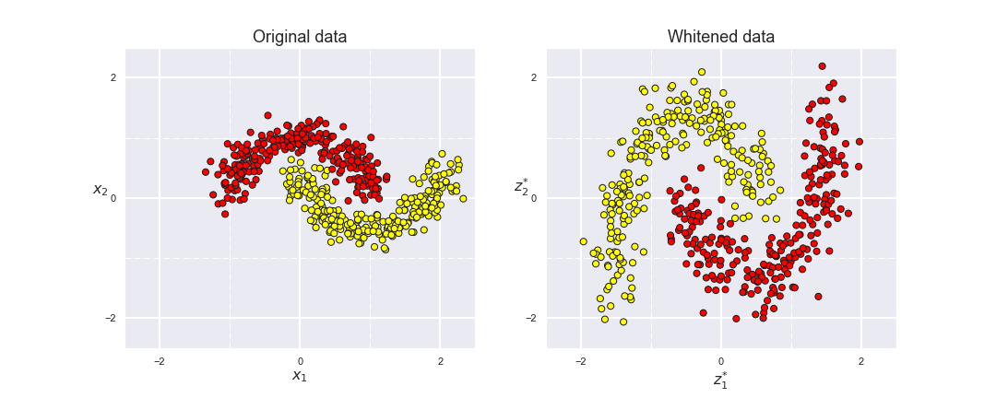

**------------------------------------------------------------------------------------------------------------------------------------------**

**Description :**

**Example of Multidimensional Scaling**

13.4_Generate_north_american_city_distribution_using _MDS.ipynb

13.4.1_Scree_plot_for_city_distances.png

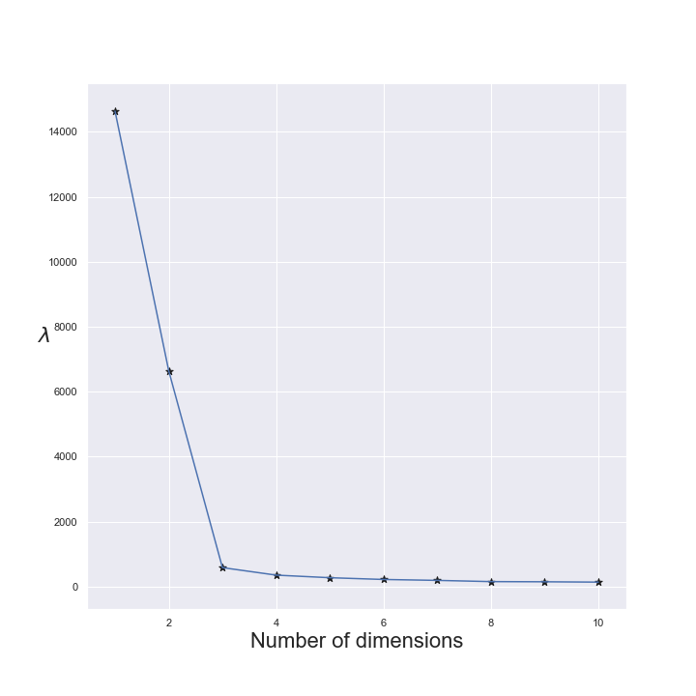

**------------------------------------------------------------------------------------------------------------------------------------------**

**Description :**

**Example of Multidimensional Scaling**

13.4_Generate_north_american_city_distribution_using _MDS.ipynb

13.4.2_City_positions_from_MDS.png

